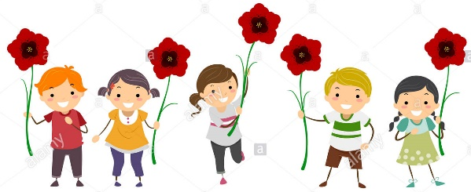
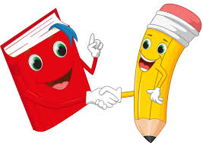
Poppy Class
Home Learning Term 1

The most important home learning you can do is to read and practise your 5 key words. Make sure you are reading a little everyday, this can be your reading book, BugClub or any book you have at home.
Completing a short maths activity each day will also help you to make good progress. This could be on Mathletics or online games such as Top Marks.
Maths  - Count to 10 or 20.  - Count backwards from 10.  - Order these numbers 7, 6, 3, 8, 1  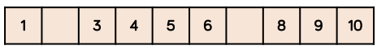  - Complete the number track  - How many different ways can you group the cakes and find the total?  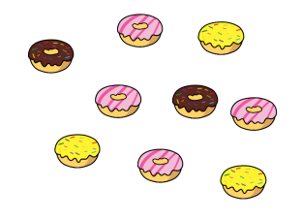  Use your fingers to help you. | English  - Make sure you can spell all of the Year R words. (You can find these on the class page)  - Write a list of adjectives to describe your favourite toy.  - Draw a picture and write about your toy. When writing continue to practise your letter formation and leaving spaces between words.  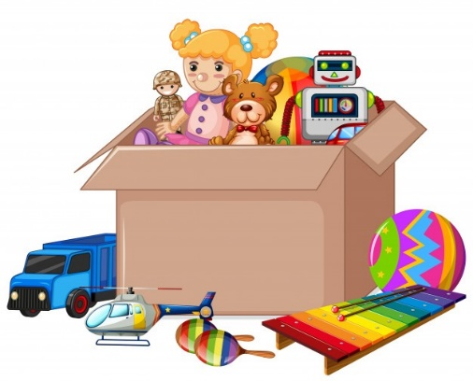
Science-Materials  - What are the toys in your house made from? Can you sort them into groups of the materials they are made from? Why do you think these materials are used? | History- Toys  - Ask a parent or grandparent about what their favourite toy was.  Compare it to your favourite toy.  What is the same?  What is different?
Choose 1 thing to do each week to help support learning in class.
Please bring in your homework books in on Monday 18th October to share your work.
You can use your homework books for any other English or Maths work you have been doing!

