

Poppy Class Home Learning
Term 2 Year 2

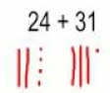  Maths  - Complete these questions. Draw tens and ones to help you.  24 + 32 = 25 – 13 =  36 + 24 = 32 – 13 =  28 + 23 = 35 – 17 =  29 + 29 = 42 – 15 =  - Add and subtract 10 to these numbers.  Look at a 100 square to help you. 7, 23, 54, 83, 99  - Memorise the number pairs to 20  0-20, 1-19, 2-18, 3-17, 4-16, 5-15, 6-14, 7-13, 8-12, 9-12, 10-10.  - Play ‘Hit the Button’ number bonds on www.topmarks.co.uk | English  - Practise your precision teaching words for 5 minutes everyday!  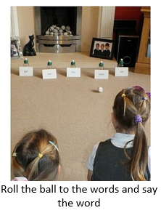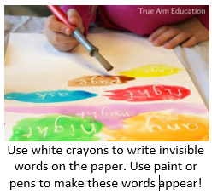  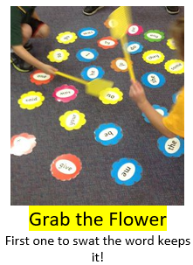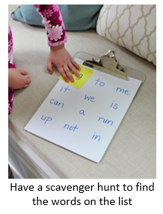
Geography- West Malling  - Draw and label a picture of your favourite place in West Malling. Write sentences to explain why you love it there. | Science- Seasonal Change  - Go for an autumnal walk or look at autumnal changes where you live, even in your garden! Take photos or collect leaves, conkers etc.  - Have you noticed how animals are getting ready for winter? Find out how you can help your local wildlife this winter:  www.rspca.org.uk/adviceandwelfare/seasonal/wildlife/winter
Choose 1 or 2 things to do each week to help support learning in class. Some may take longer than others and some may need to be practised more often.
Please bring your homework books in on Monday 13th December to share your work. Please use your homework books for any other English or Maths work you have been doing. They are a great place to draw and to do some extra writing practise.

