

Poppy Class Home Learning
Term 3 (Year 2)

Maths Find these on Mathletics!  - Practise the 2, 5 and 10 times tables. Start by skip counting eg. 2 4 6 8 10 12.  It will help to practise writing them out.  - Have a go at counting different amounts of money. Draw the coins you use and see if you can write it as an addition sentence. Play shops!  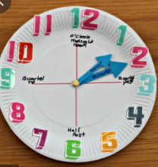  - Have a look at a digital and analogue clock. Practise telling the time to o’clock, half past, quarter past and quarter to. Make a paper plate clock to help you!  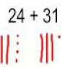  - Practise adding 2 digit numbers. Either by drawing tens and ones, or using the column method.  For example 24 + 31 = | English  - Keep practising your precision reading words  - Spell them using magnetic letters, stamps, playdough, in flour, paint etc.  - Write a list of nouns, adjectives and verbs.  - Draw an imaginative picture.  Label it and write sentences to explain what is happening.  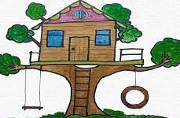
  Noun  Who? What? | Adjective  What like? | Verb  What doing?
  eg. dog | eg, red | eg. run
Geography- India  - Think of a way to help you remember the 7 continents and 5 oceans of the world.  - Use an online map to find India.  Which continent is it in?  What is the capital city? | Science- Animals  - What is your favourite animal?  Find out 3 new facts about it.  - Write a list of animals you can find in England and in India.  What are the differences?
Choose 1 or 2 things to do each week to help support learning in class. Some may take longer than others and some may need to be practised more often.
Bring your homework books in on Monday 7th February to share your work and receive castle points.
Please also send in photos/ brief description of Weekend News as this will be shared each Monday!

