
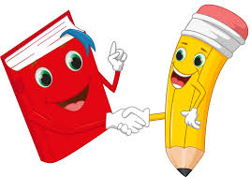
Poppy Class Home Learning
Term 3 (Year 1)

Maths  - Practise your number bonds to 10 Play ‘Hit the Button’ number bonds on Topmarks: www.topmarks.co.uk  - Have a go at identifying different coins and notes. Draw or make rubbings of different coins. Can you add up 1ps and 2ps? Play shops!  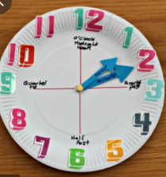  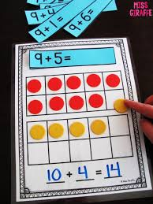  - Have a look at a digital and analogue clock. Practice telling the time to o’clock and half past. Make a paper plate clock to help you!  - Practise adding 1 digit  numbers  All can be found on  Mathletics | English  - Keep practising your precision reading words  - Spell them using magnetic letters, stamps, playdough, in flour, paint etc.  - Write a list of nouns, adjectives and verbs.  - Draw an imaginative picture.  Label it and write sentences to explain what is happening.  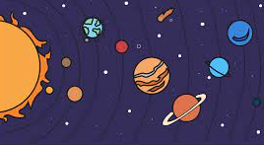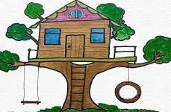
  Noun  Who? What? | Adjective  What like? | Verb  What doing?
  eg. dog | eg, red | eg. run
Geography- India  - Think of a way to help you remember the 7 continents and 5 oceans of the world.  - Use an online map to find India.  Which continent is it in?  What is the capital city? | Science- Animals  - What is your favourite animal?  Find out 3 new facts about it.  - Write a list of animals you can find in England and in India.  What are the differences?
Choose 1 or 2 things to do each week to help support learning in class. Some may take longer than others and some may need to be practised more often.
Bring your homework books in on Monday 7th February to share your work and receive castle points.
Please also send in photos/ brief description of Weekend News as this will be shared each Monday!

