

Poppy Class Home Learning
Term 4 (Year 1)

Maths Find these on Mathletics!  - Practise counting and writing numbers to 20  - Songs:  https://www.youtube.com/watch?v=_MVzXKfr6e8  https://www.youtube.com/watch?v=0VLxWIHRD4E  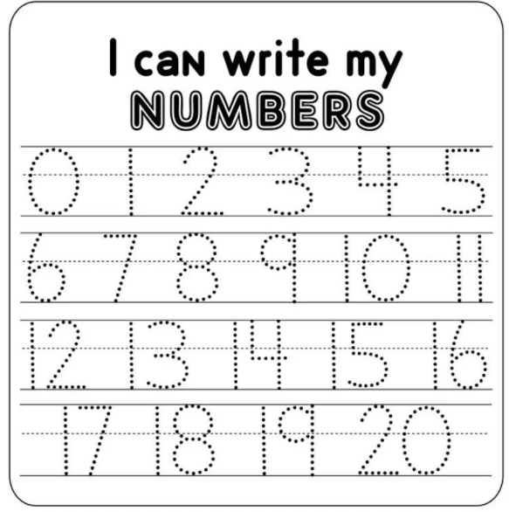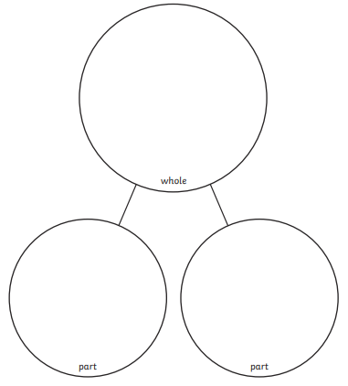  - Find different ways to make 20. Use a part-whole model (above) Be creative with numbers, toys, pasta etc  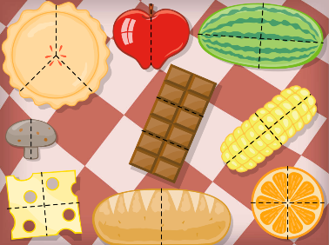  - Have a go at cutting fruit into halves and quarters. Make sure they are in equal parts!  - Practise paying for items with this game:  https://www.ictgames.com/mobilePage/payForIt/index.htm | English  - Keep practising your precision reading words  - Spell them using magnetic letters, stamps, playdough, in flour, paint etc.  - What can you see?  Label a picture and write sentences to describe it using ‘Who/What?’, ‘What like?’ and ‘What doing’ words.    e.g. The girl is sliding down the orange slide.
  Noun  Who? What? | Adjective  What like? | Verb  What doing?
  eg. dog | eg, red | eg. run
History- Communication  - Write a message in morse code or create your own alphabetical code!  - What invention would you design to change the world? Draw a picture or make a model of your idea! | Science- Animals  - Keep a food diary for a week  - Design a healthy meal or lunch box  - Make a ‘Keep Fit’ Video for Poppy Class
Choose 1 or 2 things to do each week to help support learning in class.
Bring your homework books in on Monday 28th March to share your work and receive lots of castle points!
Please also send in photos/ brief description of Weekend News as this will be shared each Monday!

