

Poppy Class Home Learning
Term 5

Maths  - Telling the time is tricky, but the only way to get better is to practise, practise, PRACTISE! Start with o’clock, then move on to half past, quarter past/to and then to 5 past, 10 past etc.  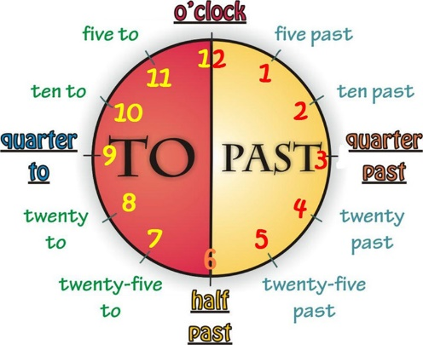  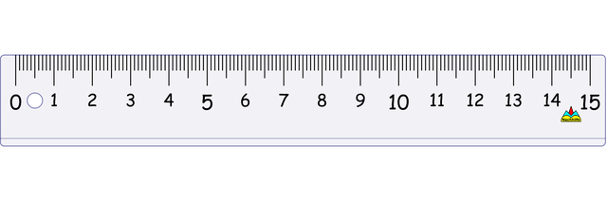  - Have a go measuring objects around the home with a ruler or tape measure Write a list in your book, remember to use the unit (cm, m) | English  - Keep practising your precision reading or spelling words  - Reading – write them on cards and play skittles, splat, or have a ‘treasure’ hunt  - Spelling - magnetic letters, stamps, playdough, in flour, paint etc.  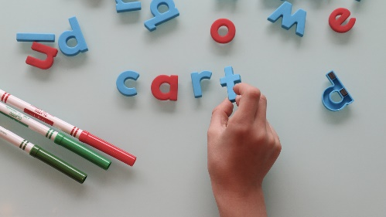  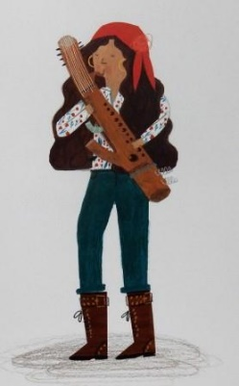  - Design a musical instrument just like Ossiri did. Write sentences to describe it, underline the adjectives in your work and see if you can improve them
History- Flight  - Find out about space travel  - What type of flying machine would you design?  Where would it go? What could it do?  - Draw a picture or make a model of your idea! | Science- Plants  - What plants do you have at home or in your garden?    - Have a go at planting some seeds and watch them grow!  - Plant a new tree
Choose 1 or 2 things to do each week to help support learning in class.
Bring your homework books in the last week of term to share your work and receive lots of castle points!
Please also send in photos/ brief description of Weekend News as this will be shared each Monday!

