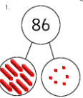
Poppy Newsletter Term 6

Computing 
In our new project, ‘We are Treasure Hunters’, we will be using programable robots to solve problems involving position and direction. This will also consolidate and enrich our learning in Maths.
English
Our Power of Reading book this term is called ‘The Fox and the Star’ by Coralie Bickford-Smith. Fox’s only friend is Star who lights his way through life. Then one night, Star does not appear. In a story which resembles the pattern of a traditional tale, Fox goes in search of his lost companion.

We will be writing a range of purposes, including an information text (non-chronological report about Foxes), poetry, riddles and a diary extract.

Please read every day and practice the Precision Teaching reading words and spellings at home.


Science
Our topic ‘Living things and their habitats’ will include local and global habitats, exploring how living things adapt and depend on each other to survive.

Geography
‘Wonderful Weather’. We will be exploring global climates and setting up a weather station to investigate the weather where we live.

Art
Our topic explores landscapes using different media, following a forest theme. We will be studying ‘The Avenue’ by famous impressionist painter, Claude Monet to learn about composition and the horizon line; colour mixing of shades, tones and hues; and to recreate textures.
Welcome back! We hope you had a lovely Jubilee break and are looking forward to the term ahead.

Maths
Group 1-Year 1 curriculum
- Place value to 50
- Multiplication – counting in 2s, 5s and 10s
- Position and direction- half, quarter and full turns; describing position
- Weight and volume

Group 2- Year 2 curriculum
- Fractions halves, quarters and thirds.
- Weight, capacity and temperature
- Position and direction
- Statistics- pictograms and block graphs

RE 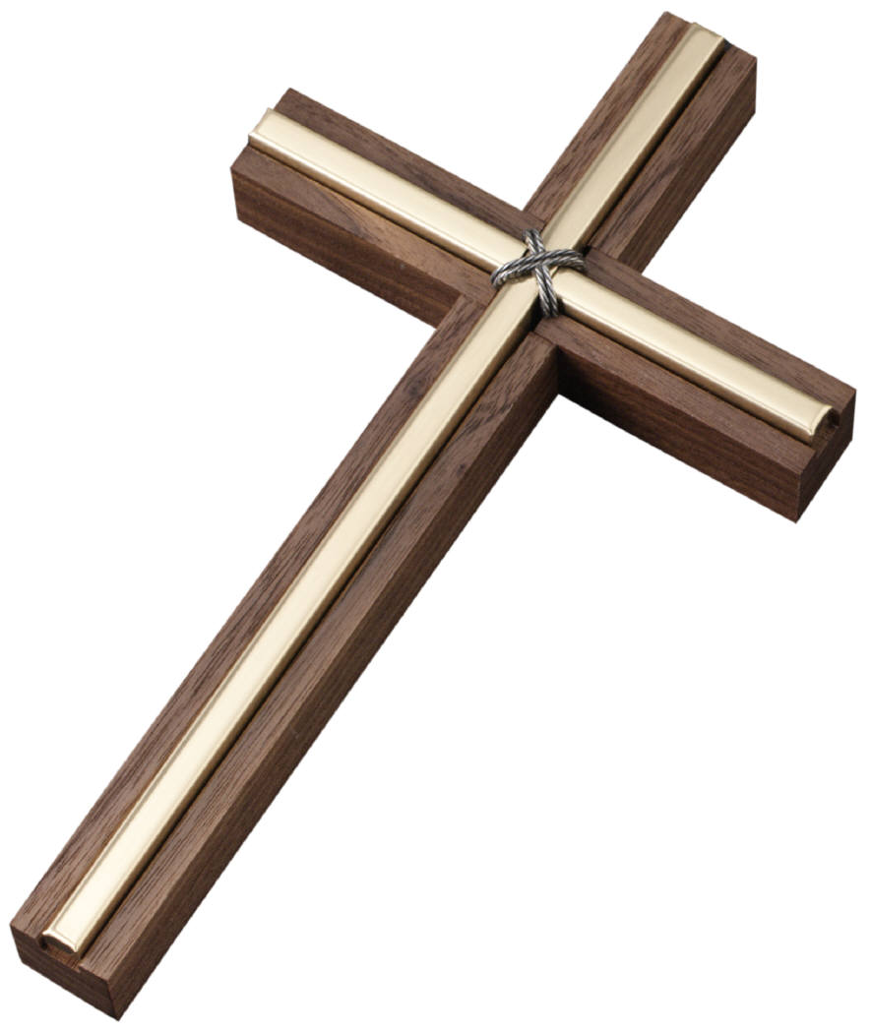
Our big question ‘Who is a Muslim and what do they believe?’ will now explore how Muslims worship and the festival of Eid El-Fitr.
Notices

PE will continue to be on Tuesdays. Poppy will also include in Lime/Cherry for Music and Jigsaw.

Please ensure your child brings a water bottle and sun hat into school every day. Sun screen must be applied by your child in school, a roll-on is better for easy application.

Each day, children are expected to do a short reading and maths activity at home to make good progress. This may include Topmarks, ICT Games, Mathletics or BugClub.

Reading books must be read frequently through the week and brought back to school when finished.
Please practise the precision reading or spelling words daily.
Home learning is to be completed through the term and due back in the last week of term.

Thank you for your continued support and we look forward to the term ahead. Please do email if you have any questions or catch us at the end of the school day.

sogden@west-malling.kent.sch.uk Mrs Ogden, Mrs Mac, Miss Skelly, Miss Rolfe and Mrs Hook

