
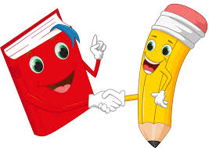
Poppy Class Home Learning
Term 6

Maths  - Tick-tock! Keep practising telling the time  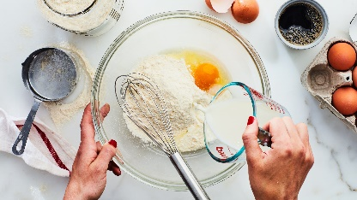  - British Bake Off! Have a go at weighing out and measuring ingredients for recipes, using scales and a measuring jug.  - Find out which cups or containers hold most water and order them  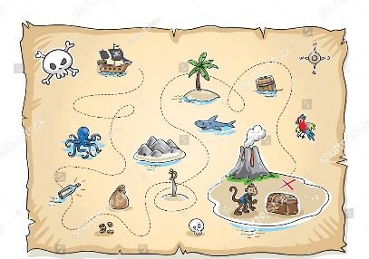  - Land Ahoy! Practice points of the compass Draw a treasure map and give directions to the treasure, using North, South, East and West  - See if you can include half or quarter turns clockwise/ anti-clockwise in your directions | English  - Keep practising your precision reading or spelling words  - Reading – play snakes and ladders or noughts and crosses  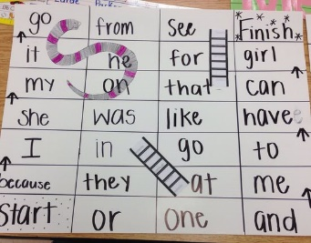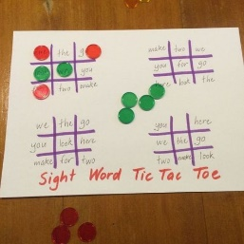  - Spelling – play Scrabble, Boggle or make your words with the tiles  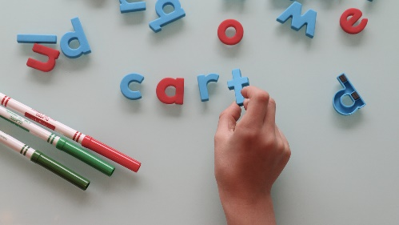  - How many words can you think of to describe the stars? Can you use them to write an ‘Ode to the stars’ like the fox in our new story?
Geography – Wonderful Weather  - Watch the weather forecast- or ask Alexa what the weather will be like!  - Film your own weather forecast to share with your friends at school  - Find a weather picture you like created by a famous artist. Paint your own weather picture or create a collage | Science- Living things and their habitats  - What lives in your garden?  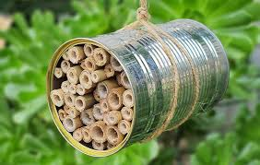  - Have a go at making a bug hotel  - Feed the birds that visit your garden  - Plant flowers that attract butterflies and bees
Choose 1 or 2 things to do each week to help support learning in class.
Bring your homework books in the last week of term to share your work and receive lots of castle points!
Please also send in photos/ brief description of Weekend News as this will be shared each Monday!

