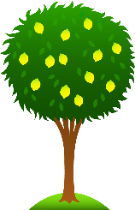 Lime Class Home Learning
Term 2
Maths  - Continue to practise writing numbers 1-20 correctly. Please help your child to write these numbers correctly. (You could use paints, chalk, pens).  - Practise number bonds to 10. What goes with 6 to make 10? What goes with 2 to make 10? (Use fingers to help!)  - Can you find a rectangle, circle, square or triangle in your house? Take a photo/ draw what it is. E.g. a rectangle might be a dinner place mat or a circle might be a clock.  - Can you fill in these part whole models?  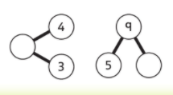  - Practise logging into Mathletics independently. | English  - Create a character description of any fairy tale character – What do they look like? How do they feel? What do they do?  - Practise these red words:  I, the, you, your, said, was, are, of, want, what, they, to.  Can you read them? Have a go at writing them either as a list or in a sentence – I want to play. They are at the zoo.  - Learn the letter names of the letters in the alphabet.  - Practise logging into Bug Club independently.  RE  - Make a model of a nativity scene or re-tell the Christmas story.  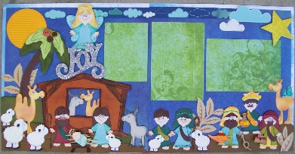
Science- Materials  - Find different objects around the house. What material is the object made from? Can you describe what the material is like? (soft, hard, smooth, rough, stretchy, transparent). | Geography- West Malling  - Draw and label a picture of your favourite place in West Malling.  - Make a list of as many different shops you can think of in West Malling. Do you know what you can buy and do in each one?
- Children can use this home learning book to record any of their investigations (they could draw pictures, do some writing, put in photographs or stick in anything they have collected).

Please bring in your Home Learning books on Monday 13th December to share your work. Please use your books for any other English or Maths work you have been doing. They are a great place to draw and to do some extra writing practise.

