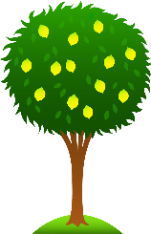 Lime Class Home Learning
Term 3
Maths  - Use objects/toys you have at home to create a subtraction number story. Can you write the subtraction number sentence to match it? (I have 8 cars, 3 drive away, how many are left? 8-3=5. I have 6 dolls, 2 go to sleep, how many are still awake? 6-2=4).  - Continue to practise using part whole models to create addition and subtraction number sentences.  - Practise finding 1 more and 1 less than any given number up to 20. Can you write the numbers?  - Can you find any 3D shapes in your house? Take a photo/ draw what it is. E.g. a sphere might be a ball or a cube might be a dice.  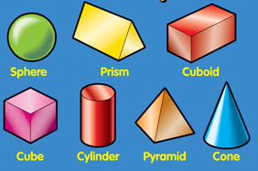 | English  - Find a non-fiction (real or on Bug Club). Have a go at locating and using the contents and index pages. Read it with an adult and write a sentence to explain something that you learnt/found out.  - Practise these red words:  he, me, we, she, be, no, so, go, old, her, do.  Can you read them? Have a go at writing them either as a list or in a sentence – We can go and play. Do you like her hat?  - Practise writing the letters of the alphabet as capitals and lower case.  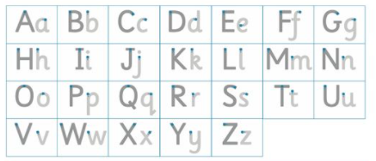  - Have a go at reading some of the nonsense words on the sheet sent home (it is also on our class webpage).
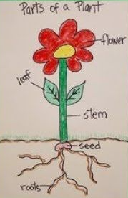  Science- Plants  - What different plants can you find in your garden or in a local park?  - Create a picture or a model of a plant and label the key parts – roots, stem, leaf, flower. |   Geography- India  - Find out what the 7 continents of the world are.  - Use an online map or an atlas/globe to find India. What continent is it in? Can you find out a fact about India? (E.g. what language they speak, what animals you would find there or famous landmarks).

Please bring in your Home Learning books on Monday 7th February to share your work. Please use your books for any other English or Maths work you have been doing. They are a great place to draw and to do some extra writing practise.

