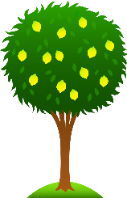 Lime Class Home Learning
Term 4
Maths  - Complete these part-whole models:  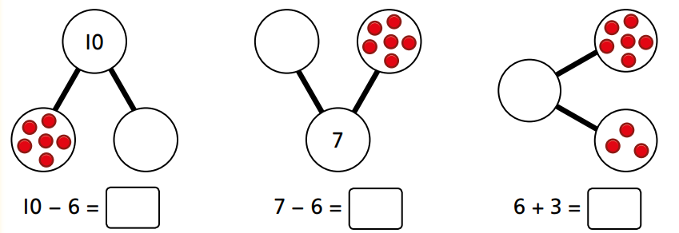  Can you draw some part-whole models for other number bonds?  - Complete the number sentences using <,> or =  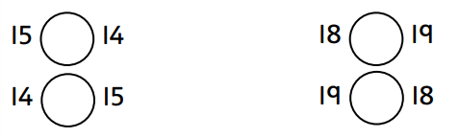  Compare some other pairs of numbers and write the number sentences.  - Work out which numbers complete the table:  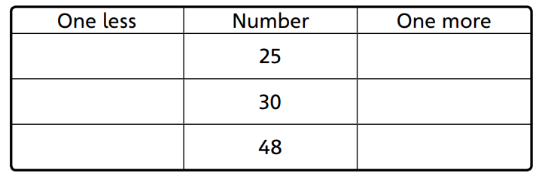 Choose a number between 0 and 50. Say the number that is 1 more and 1 less. | English  - Find a non-fiction (real or on Bug Club). Have a go at locating and using the contents and index pages. Read it with an adult and write a sentence to explain something that you learnt/found out.  - Practise these red words:  all, ball, call, tall, small, many, any, one, anyone, some, come.  Can you read them? Have a go at writing them either as a list or in a sentence – Can I come to the park? How many pets do you have?  - Practise forming your letters correctly.  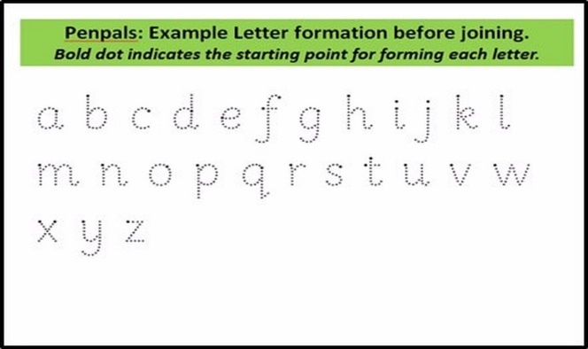  - Keep reading the real words and nonsense words that are sent home.
Science- Animals  - What is your favourite animal? What animal group does it belong to? Is it a bird, mammal, fish, reptile or amphibian?  - Find out what animals are carnivores, herbivores or omnivores. Draw or write the animal names for each one. | History of communication  - Find out how people used to communicate with each other before we had mobile phones.  - Can you create a way for people to communicate with each other?  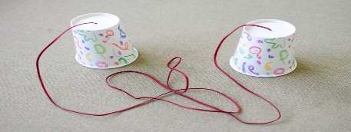

Please bring in your Home Learning books on Monday 28th March to share your work. Please use your books for any other English or Maths work you have been doing. They are a great place to draw and to do some extra writing practise.

