 Lime Class Home Learning
Term 5
Maths  - Practise counting in 2s, 5s and 10s – forwards and backwards.  - Use a 100 square to practise counting and reading numbers. What patterns can you spot? Cover up some numbers – what numbers are missing?  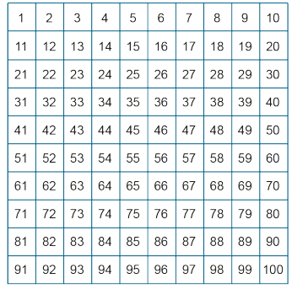  - Compare the height of 3 different objects. Which is the tallest? Which one is the shortest?  - Can you find an object in your house that is shorter/longer than 10cm? Use a ruler to help you. | English  - Design a musical instrument just like Ossiri did. Write sentences to describe it.  - Practise these red words:  watch, who, where, there, here, were, other, brother, mother.  Can you read them? Have a go at writing them either as a list or in a sentence – Where is the hat? Come here now! There is a slide at the park.  - Keep practising to form your letters correctly.  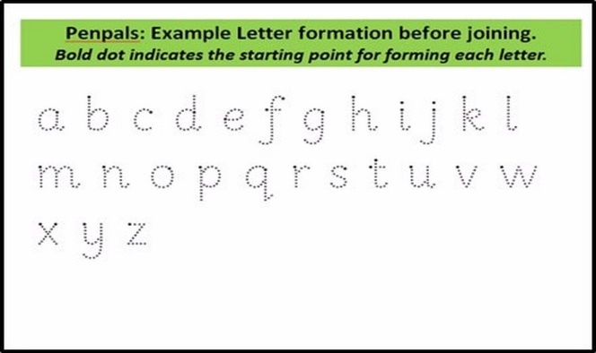  - Keep reading the real words and nonsense words that are sent home.
Science  - Can you name the parts of your body?  - Can you come up with a senses game? A listening game, a looking game or a tasting game etc.  - Draw and label a healthy meal that you have eaten. | History of flight.  - Invent a new space shuttle. Think about what features it will need and what experiment it may carry out.  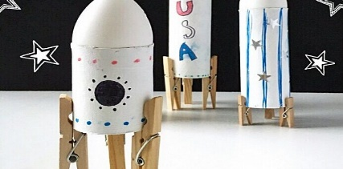  - Research the Wright Brothers. Write 2 or 3 facts about them.

Please bring in your Home Learning books on Monday 23rd May to share your work. Please use your books for any other English or Maths work you have been doing. They are a great place to draw and to do some extra writing practise.

