 Lime Class Home Learning
Term 6
Maths  - Practise counting in 2s, 5s and 10s – forwards and backwards.  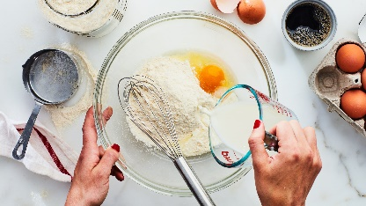  - Great British Bake Off! Have a go at weighing out and measuring ingredients for recipes, using scales and a measuring jug.  - Find 3 or 4 objects of different lengths/heights. Can you order them form the tallest to the shortest, longest to the shortest?  - Find out which cups or containers hold most water and order them.  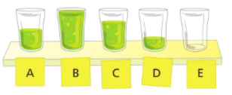 |   English  - If you can, visit the library and choose a story book. Firstly, enjoy reading the story then think about what you like and dislike about it.  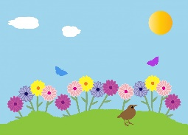  - Our book is about creating a special garden. Can you write some interesting sentences about your garden? Have a go at using the word ‘and’ to join two ideas together.  - Have a look at the Year 1 words (you can find these on the class webpage). How many can you read and write? To challenge yourself, can you write some silly sentences using them?
Science  - Feed the birds that visit your garden.  - Plant some flowers that attract butterflies and bees.  - Have a go at making a bug hotel.  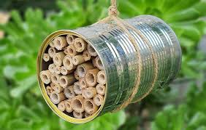 | Wonderful Weather.  - Watch the weather forecast- or ask Alexa/Siri what the weather will be like!  - Create/film your own weather forecast to share with your friends at school.  - Find a weather picture you like created by a famous artist. Paint your own weather picture or create a collage.

Please bring in your Home Learning books on Monday 18th July to share your work. Please use your books for any other English or Maths work you have been doing. They are a great place to draw and to do some extra writing practise.

