
Welcome back! We hope you had a lovely Jubilee break and are looking forward to the term ahead.
Below is a summary of what we will be learning about this term.

Literacy

Our Power of Reading book this term is about a girl who creates a beautiful garden and discovers a new friend. It is a wonderful story sharing the impact small actions can make on a community and on ourselves. It may also encourage children to value and consider how to improve their own environment.

We will be practising to use our phonic knowledge to write sounds in words and to develop our use of correct sentence structure when writing for different purposes.

Topic

Science
In Science we will be revisiting each of the topics we have covered this year – Seasonal changes, Plants, Materials and Animals including Humans - through some fun mini quizzes.

Art
We will be exploring shape, line and colour: mixing and painting with secondary colours, using circles to create abstract compositions and working collaboratively to create a class piece of art inspired by water.

Geography
This term our topic is ‘Wonderful Weather’. We will be exploring global climates and setting up a weather station to investigate the weather where we live.

Numeracy

We will be:
- Counting in 2s, 5s and 10s.
- Position and direction- half, quarter and full turns; describing position
- Comparing and measuring lengths and heights.
- Comparing the weight and capacity of objects.
- Division – making equal groups and sharing amounts equally.
- On Fridays we will continue to complete the 30/60 club challenges to practise our mental maths skills.
RE 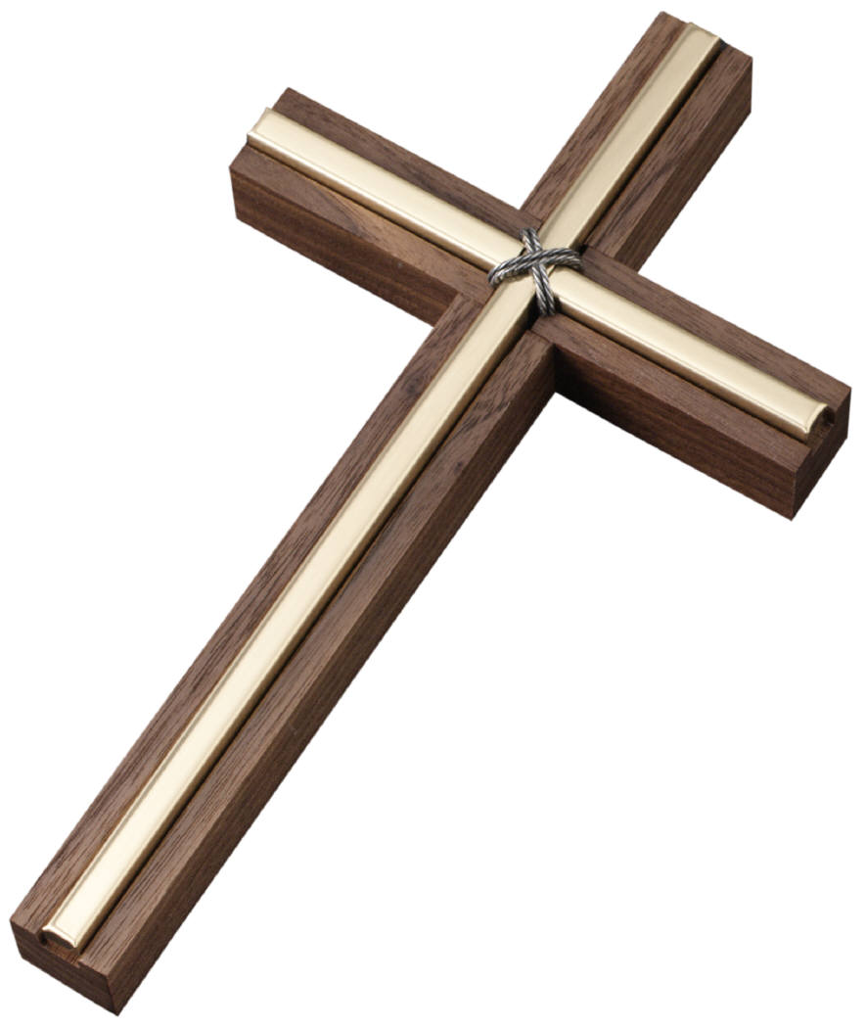

In RE, we will be continuing our learning on Judaism. We will be finding out about their place of worship and the Torah.
Computing

In Computing the children will be creating a multimedia eBook using Book Creator on the iPad. They will be learning how to add images, audio and text to their eBook.

Reminders 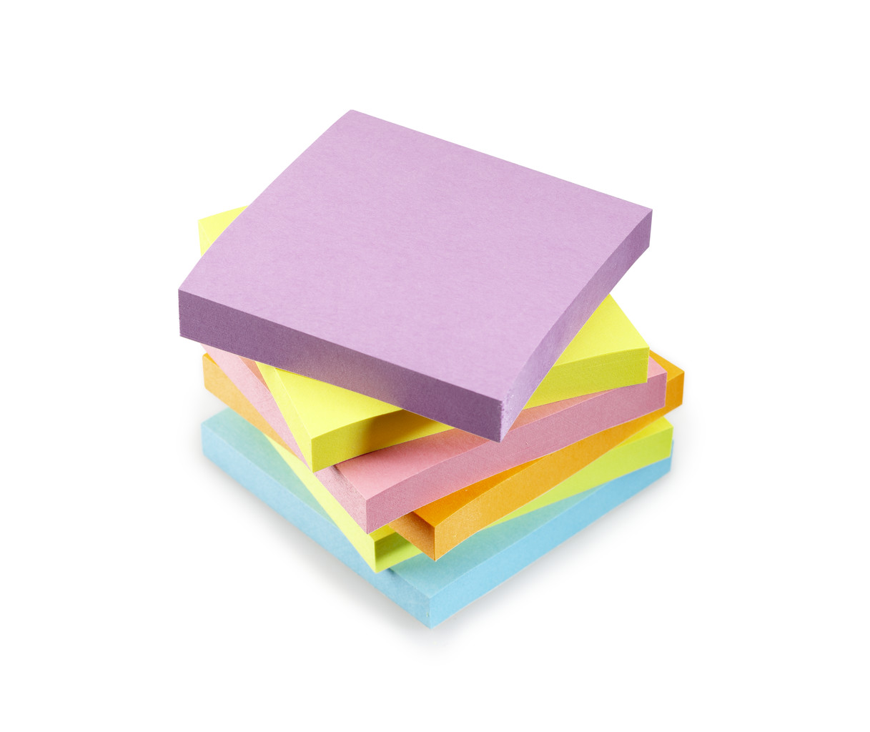
Please try to complete a short reading and maths activity each day. This could be using Bug Club or Mathletics, or using online games such as Phonics Play or Top Marks. Please continue to bring in reading books on a Friday so that they can be changed. We will also be updating and monitoring Bug Club each week.

PE will continue to be on Tuesdays and Thursdays. Please come to school in your PE kit. Earrings need to be taken out or covered on these days.

Please ensure that any clothing and belongings brought into school are clearly named including water bottles, lunch boxes, book bags, all items in their PE kit and school uniform. Please ensure your child brings a water bottle and sun hat into school every day. Home learning is due in on Monday 18th July.
Thank you for your continued support and don’t forget to check our class page on the school website to find out more about what we have been doing. Please do contact us if you have any questions, messages or queries at limeteacher@west-malling.kent.sch.uk
Mrs Woodhouse and Mrs Harris

