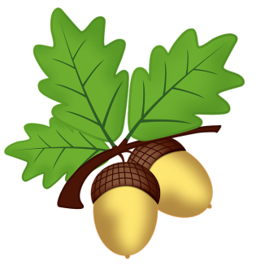
West Malling C. E. Primary School
Oak Class
Curriculum Newsletter: Term Three 2023-24

Dear Parents and Carers,
We hope you all had a restful break and your children are looking forward to the term ahead. Please do not hesitate to speak us or email on oakteacher@west-malling.kent.sch.uk should you have any questions or queries.

Homework
Reading – Children should read EVERY day. Everyone will have a book in their tray which they are reading at school, they are welcome to also take this home to read.
Maths – Mathletics and times table practise will form the maths homework, it is expected that this is done at least once a week. By the end of this academic year the children are expected to know their tables up to 12 x 12, and this will be tested in June when they complete the Multiplication check. You can find a link of the class page to a site which is similar to the Multiplication Check. The order in which we learn the X tables is: 2x, 5x, 10x then 3x, 4x, 8x then 6x, 7x, 9x, 11x, 12x.
There is a sheet at the back of their homework book for you to sign when they have read and completed a Maths task at home. Children are rewarded with cerificates and raffle tickets when they reach a milestone.
Spellings – Children will have spellings to practise each week, linked to learning in class. Please make sure that children practise spelling them correctly in a sentence.
Weekly homework – This will be set at the beginning of each term. We hope that they are fun and interesting activities that will develop them as learners. It will be given out on a Friday and is due in on a Wednesday. There will be a different activity for each week and castle points will be awarded generously.

Useful Reminders
Please ensure everything is clearly named including PE hoodies, lunch boxes and especially JUMPERS. Nothing beats writing a name with a permanent marker as it can’t fall off and takes a while to wash off. Please remind your child that their belongings should stay either ON their peg or by their desk, this way nothing should get lost.

PE
We will be going swimming on Mondays, please come to school in PE kits to help with changing. It is vital that all children wear goggles to fully partake in lessons, they are unlikely to be able to pass onto the next level without goggles. PE will on Fridays. Please ensure that earrings are removed on PE days and that long hair is tied back. We will not be doing PE on Thursdays during terms 3 and 4.

Break time
Please remember to bring a piece of fruit or vegetable to have at break time, this gives a much needed energy boost.

Dates for your diary
Tuesday 2nd January Inset Day
Wednesday 3rd January Term 3 starts
Friday 12th January non-school uniform day
Monday 15th January school clubs start
Monday 5th – Friday 9th February e-safety week and Mental Health Week
Friday 9th February End of term 3

