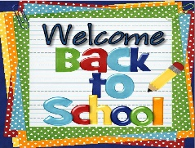 Lime Class - Term 1 

Welcome back! We hope you had an enjoyable summer and are ready for the new school year. We are looking forward to an amazing year!
If you ever have any questions, please do speak to us at the end of the day, via the class email limeteacher@west-malling.kent.sch.uk or by writing in the reading record books.

PE will be on Monday and Friday and children need to come to school in their PE kits. Earrings need to be taken out or covered at home. Please ensure that any clothing and belongings brought into school are clearly labelled including water bottles, lunch boxes, book bags, all items in their PE kit, school uniform and coats. Please ensure your child brings a water bottle into school every day that only contains water. Fruit is provided each day for playtime, but children are welcome to bring in their own piece of fruit or vegetable for their snack.

Home learning will be set next week and is to be completed throughout the term. It is due on Monday 16th October. Each day children are expected to do a short reading and maths activity at home. It is vital to practise these keys skills every day to help your child to make good progress. This may include Mathletics, BugClub or practising the year 1 spellings. Further ideas can be found on our class page on the school website.

Reading Books
Children will be bringing home a reading book every Friday. Please keep these at home to read until the following Thursday when they will need to be brought back into school to be changed. It may be helpful if children could bring a book bag or small rucksack with them so that the reading books can be easily transported between home and school.

Packed Lunches
Please remember that there should be no sweets, chocolate bars or nut products in lunch boxes. Can all children please have a separate drink for their packed lunch to prevent any lost or forgotten water bottles and from a safety aspect because the classroom is unattended during the lunch hour. Children can have a soft drink/squash/fruit shoot as part of their lunch should they wish.

Ties
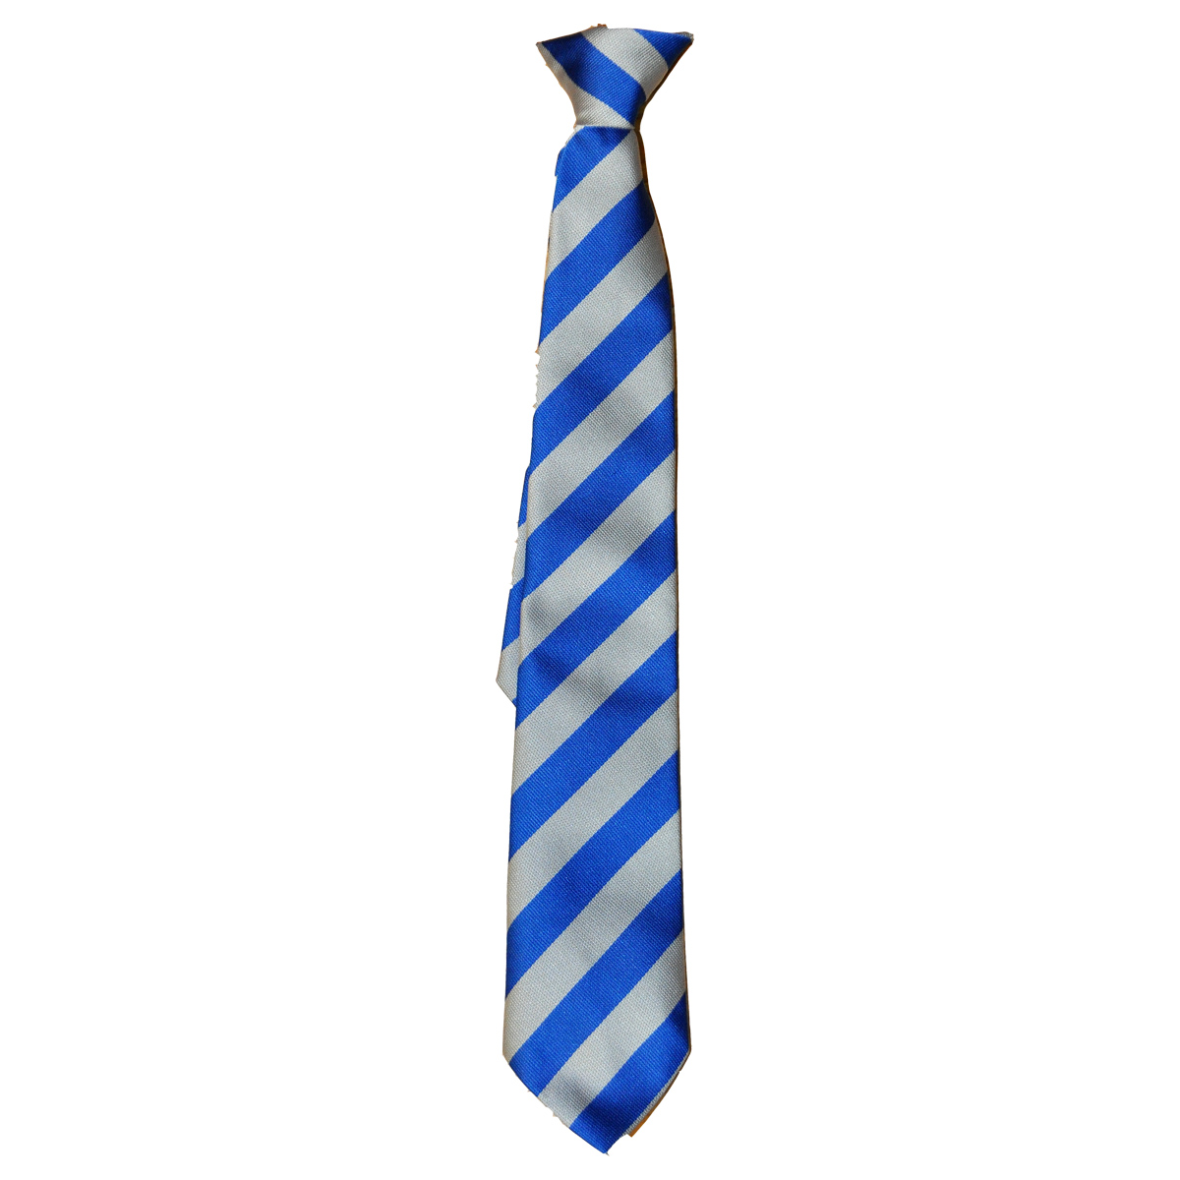Just a reminder that all children in Year 1 need to wear a school tie as part of their uniform. Thank you.

Thank you for your support and we look forward to a great year ahead. Don’t forget to check our class page on the school website.
Mrs Woodhouse, Mrs Harris and Miss Williment.

