
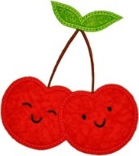
Cherry Class Home Learning
Term 3

Maths  - Practise the times tables we have learnt, the 2, 5 and 10 times tables. Start by skip counting e.g. 2 4 6 8 10 12.  If you are already confident, challenge yourself to learn the 3s and 4s too. It will help to practise writing them out.  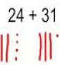  - Keep practising adding 2 digit numbers. Remember drawing tens and ones will help you.  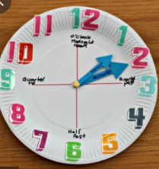  - Have a look at a digital and analogue clock. Practice telling the time to o’clock and half past.  - Keep practising subtraction. Remember to use a number line or draw tens and ones (and cross out the tens and/or ones you don’t need anymore) to help you.  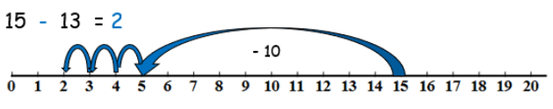 | English  - Keep learning the Year 2 common exception words.  You can find a full list of Yr 1 and 2 tricky words on the class page.  Write a sentence using each of these.  Every great break pretty beautiful after class grass pass fast last past father mother brother sister  - Can you name 5 nouns, adjectives and verbs? Then write 10 sentences including some of the words from your list.  - Draw an imaginative picture.  Label it and write sentences to explain what is happening.  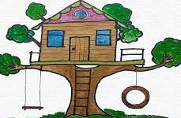
  Noun-  place, person, thing | Adjective- describing word | Verb- action word
  eg. Dog | eg, red | eg. Run
Geography- India  - Think of a way to help you remember the 7 continents and 5 oceans of the world    - Use an online map to find India  Which continent is it in?  What is the capital city?  Describe the climate. | Science – Plants  - Do you have a favourite plant?  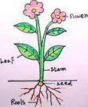  - Look up 5 common plant species in the UK.  Draw a picture of a plant and label the key parts: root, stem, leaf and flower.
Choose 1 or 2 things to do each week to help support learning in class. Some may take longer than others and some may need to be practised more often. Bring your homework books in on Monday 5th February to share your work and receive castle points.

