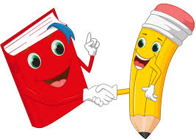
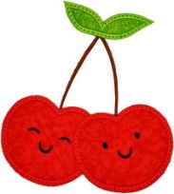
Cherry Class Home Learning
Term 4
Maths – Multiplication  - Keep practising the times tables you know. You should all know how to work out the 2, 5 and 10 times tables by counting  up.  E.g. 4 x 5 = 5, 10, 15, 20  6 x 2 = 2, 4, 6, 8, 10, 12  Remember that we say groups of instead of times.  If you have mastered this have a go at other times tables.  - This is an array; they can help you with your multiplication.  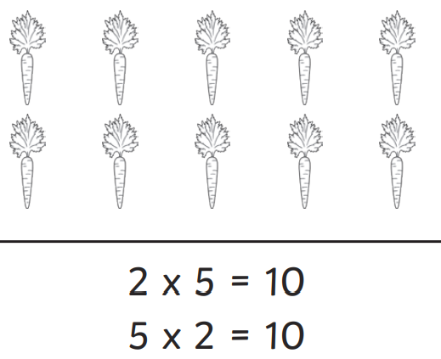  - Can you make some arrays of your own? 5x3=___, 10x4= ____, 2x8= _____ | English  - Keep practising your handwriting. Remember you do not need to join all letters yet.  - Make sure letters are the right size and height.    Ascending letters are tall letters like the d in said.    Descending letters are letter which go under the line like the y in you.  - Write about your favourite memory. Make sure you are writing in first person (I, my and I’m) and in the past tense (walked and felt). You can include an illustration of this memory.  - Keep practising the spelling of the Year 1 and Year 2 words. It will help you to remember them if you write them in sentences.
Science - Materials  - Have a look around your kitchen and see what materials have been used to make the things you can see. Are they: stretchy/stiff, shiny/dull, rough/smooth, bendy, waterproof or absorbent?  - Help with recycling at home. Which materials can be recycled?  - Can you think what new object they may be turned into? | History - Stone Age  - People in the Stone Age needed shelter to keep them warm and dry and protected from wild animals; to be able to hunt and find food and to be able to make clothes to keep them warm.  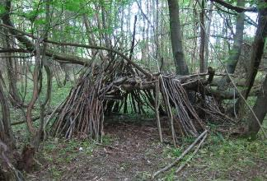  - Try and build a den outside and think about how you could make it strong and secure.
Choose 1 or 2 things to do each week to help support learning in class. Some may take longer than others and some may need to be practised more often.
Bring your homework books in on Monday 25th March to share your work and receive castle points.

