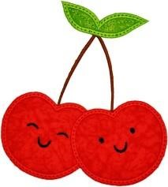
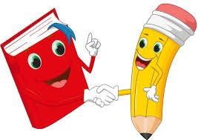
Cherry Class Home Learning Term 5
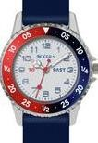  Maths  - Tick-tock! Keep practising telling the time on either an analogue or digital clock. It would be a great idea to start wearing a simple watch.  - Keep practising your 2, 5 and 10 times tables. When you are confident, keep challenging yourself. The order we teach times tables are 10, 2, 5, 3, 4, 8, 6, 9, 11, 12.  Make sure you can recall the related division facts too.  Eg. 2 x 10 = 20 20 ÷ 10 = 2  (lots of) (grouped into)  - Challenge yourself to do some tricky addition and subtraction problems.  Draw base 10 or use the column method.  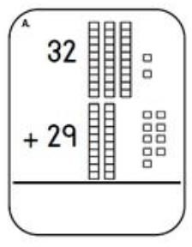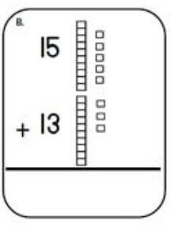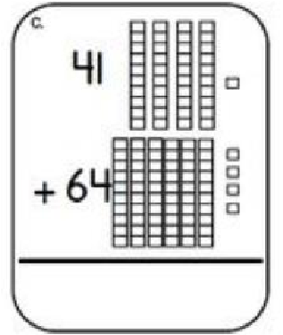 | 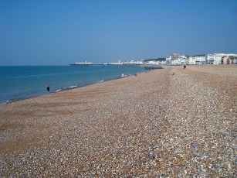  English  - Our book is set on a beach, write some interesting sentences about a beach.  Use the conjunctions ‘and’, ‘so’, ‘but’ to join two ideas together. Use ‘because’, ‘so’, ‘when’, ‘if’ to explain your ideas.  - Create some silly sentences using the Yr2 red words. You can find these on the website and should be able to read and spell them all by the end of the year. I have also added the Yr3/4 words if you need a challenge.  For example:  The beautiful children walked in the wild grass.  Mr and Mrs Christmas love to improve their festive clothes.  Please remember to use your neatest writing.
Science – Animals  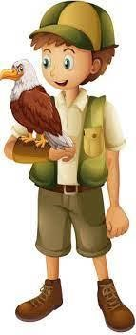  - If you could have any animal in the world as a pet, what would you choose? Which animal group does it belong to? Write about why you would love to care for this animal.  - Caring for animals is hard work, write a about all the things a zookeeper would need to do every day. | Geography- What a Wonderful World  Choose your favourite animal and research where the animal lives in the world.  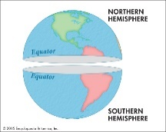  Write about which continent it lives in and if it is from a hot or cold part of the world. Is the continent near the equator? In the northern or southern hemisphere?

Choose 1 or 2 things to do each week to help support learning in class. Some may take longer than others and some may need to be practised more often.
Please bring your homework books in on Monday 20nd May to share your work and receive castle points!

