

Poppy Inclusion
Home Learning Term 1

Maths  Completing a short maths activity each day will help you to make good progress.  This could be on Mathletics https://login.mathletics.com  or online games such as Top Marks…  https://www.topmarks.co.uk/learning-to-count/place-value-basketball  https://www.topmarks.co.uk/maths-games/hit-the-button  https://ictgames.com/  Practise reading and writing numbers to 100  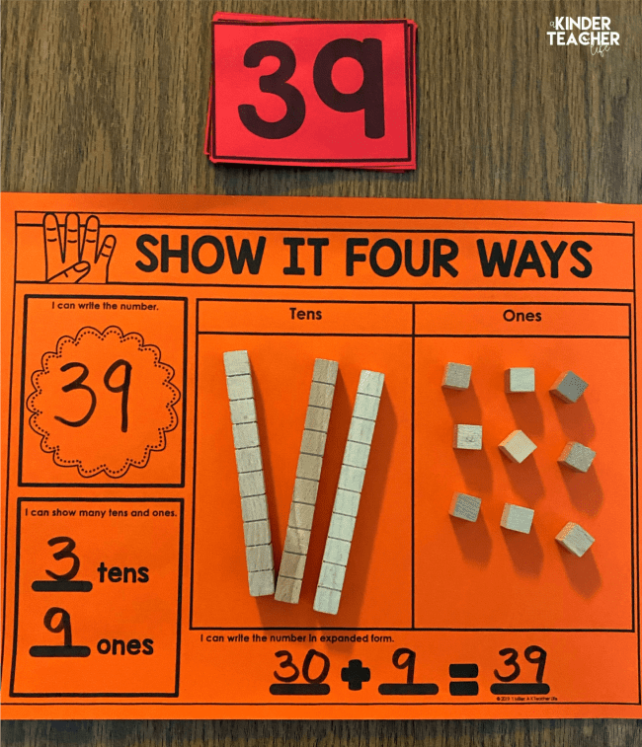  Practise building 2-digit numbers in tens and ones, you could use chocolate fingers to represent tens and smarties for ones- yum!  Can you count to 100? | English  The most important home learning you can do is to read every day and practise your 5 precision reading words.  Reading books and precision flash cards will be sent home every week.  There are some great ideas for fun multi-sensory activities to help learn to read and remember your words on the Poppy Class page.  Make sure you are reading a little everyday, this can be your reading book, BugClub or any book you have at home. Remember to write this in your reading record to earn your certificate!  20 reads = bronze certificate  40 reads = silver certificate  60 reads = gold certificate  Then every 10 reads after = 1 raffle ticket for our Christmas grand prize draw!

Please bring in your homework books in on 16th October to share your work.
You can use your homework books for any other learning, trips etc. you have been doing!

