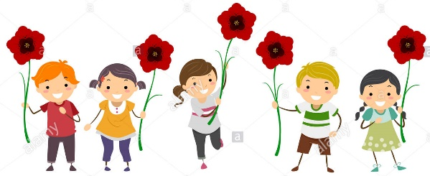

Poppy Class
Home Learning Term 1

Maths  Completing a short maths activity each day will help you to make good progress.  This could be on Mathletics or online games such as Top Marks…  (See links on the Poppy Class page)  …Or by practising writing your numbers in numerals and words.  Y1- Numbers to 10  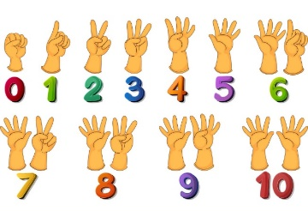  Year 2 – Numbers to 100  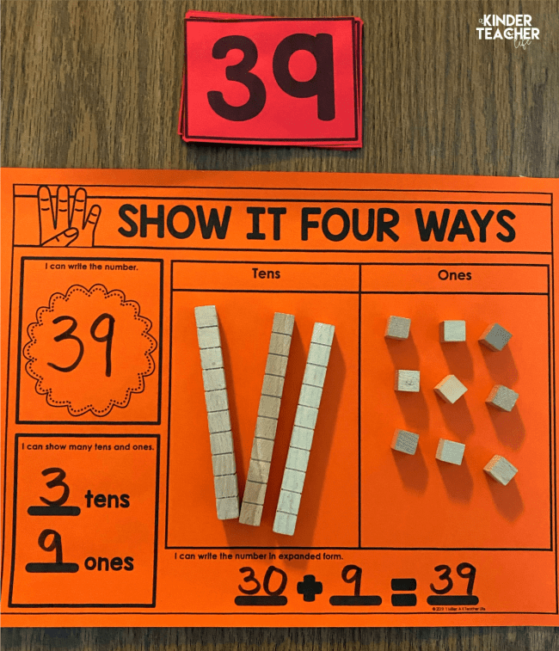  Practise representing 2-digit numbers in tens and ones, you could use chocolate fingers to represent tens and smarties for ones- yum! | English  The most important home learning you can do is to practise your 5 precision reading words every day.  Flash cards will be sent home every week.  There are some great ideas for fun multi-sensory activities to help learn to read and remember your words on the Poppy Class page.  Make sure you are reading a little everyday, this can be your reading book, BugClub or any book you have at home. Remember to write this in your reading record to earn your certificate!  20 reads = bronze certificate  40 reads = silver certificate  60 reads = gold certificate  Then every 10 reads after = 1 raffle ticket for our Christmas grand prize draw!
Science-Seasons and Living Things  - What living things can you find in your garden? Do any hibernate?  - Create a seasonal collage (leaves, acorns etc.)  - Make a hedgehog house with an adult  or a bird feeding station for the winter  https://www.hedgehogstreet.org/help-hedgehogs/helpful-garden-features/  https://www.rspb.org.uk/fun-and-learning/for-kids/games-and-activities/activities/make-a-recycled-bird-feeder/ | Topic- Douces Manor  - Find out about RAF West Malling’s history- The Beatles filmed a music video at the airfield  - Visit the monuments around Kings Hill that celebrate the pilots of WW2  https://www.warmemorialsonline.org.uk/memorial/76418

Please bring in your homework books in on 16th October to share your work.
You can use your homework books for any other learning, trips etc. you have been doing!

