

Poppy Learners
Home Learning Term 2
Name: Maths English
Poppy Maths Learners  Will you be the Mathlete of the week?! https://login.mathletics.com  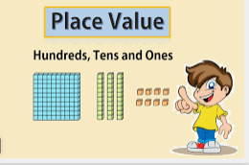  This term we are learning about 3-digit numbers!  - Practice building, reading and writing numbers up to 1000: Base 10 blocks https://ictgames.com/mobilePage/placeValuePieces/index.html  Arrow cards  https://ictgames.com/mobilePage/arrowCards/index.html  - Identify numbers to 1000 with this great game! https://ictgames.com/sharkNumbers/mobile/index.html  - Order numbers 0-999: https://www.topmarks.co.uk/ordering-and-sequencing/chinese-dragon-ordering  - Score a strike while you practise the 10, 5 and 2 x tables with Multiplication Bowling! https://mathsframe.co.uk/en/resources/resource/504/Super-Maths-Bowling-Multiplication  - Speed up mental maths: https://www.topmarks.co.uk/maths-games/hit-the-button | Poppy English Learners  - Read a little everyday, this can be your reading book, BugClub or any book you have at home. Remember to write this in your reading record to earn your certificate!  - 20 reads = bronze certificate  - 40 reads = silver certificate  - 60 reads = gold certificate  Every 10 reads after = 1 raffle ticket for our Christmas grand prize draw!  - Practise reading and spelling your 5 precision words for speedy reading and spelling.  - Reading books and precision flash cards will be sent home every week.  - There are some great ideas for fun multi-sensory activities to help learn to read and remember your words on the Poppy Class page.  - Practise forming letters correctly, including capital letters.  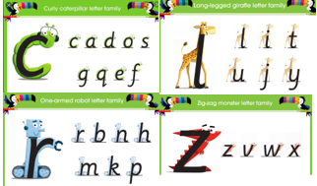  - Practice joining sentences with and, but, so, because.
Please bring in your homework books in on 11th December to share your work.
You can use your homework books for any other learning, trips etc. you have been doing!

