

Poppy Learners
Home Learning Term 4
Name: Maths English
Poppy Maths Learners  Will you be the Mathlete of the week?! https://login.mathletics.com  Speed up mental maths: https://www.topmarks.co.uk/maths-games/hit-the-button  This term we will be focusing on consolidating their understanding the value of teen numbers and the concept of tens and ones.  Children can become confused with ordering numbers beyond 10, e.g. 5 and 11 because they will have learnt that 5 is bigger than 1.  The 10 is not obvious within the names or writing of teen numbers.  The children need to consolidate their learning that teen numbers are made of ten and some ones. Real objects can help make this explicit.  Here is a useful blog with a video to explain this further:  https://www.mathshelflearning.com/blog/teaching-teen-numbers  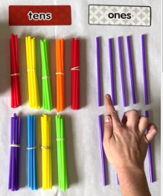  Practise building teen numbers with e.g straws/ lolly sticks- make a bundle of 10 and fasten with an elastic band then use single straws as ones:  Practice 1:1 correspondence for counting amounts to 20 accurately  Practise comparing two numbers to 20, using the straws/lolly sticks to support as necessary. | Poppy English Learners  Read a little every day, this can be your reading book, BugClub or any book you have at home. Remember to write this in your reading record to earn your certificate!  Practise learning your 5 precision words for speedy reading and spelling. Look on the Poppy Class page for multi-sensory ideas to learn your words that are fun to do!  Have a go at writing these in a sentence- remember to use a capital letter, finger spaces and a full stop.  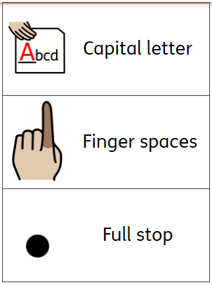  Handwriting-  Practise letter formation and capital letters-  See Poppy Class Page for parent guide.  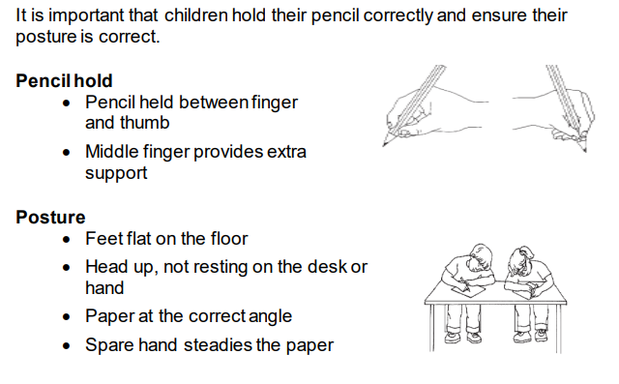
Please bring in your homework books in on Monday 25th March to share your work.
You can use your homework books for any other learning, trips etc. you have been doing!

