

Poppy Learners
Home Learning Term 4
Name: Maths English
Poppy Maths Learners  This term we will be focusing on multiplication, consolidating the 2,5 and 10 times tables  - Practise 10,2 or 5x table facts: https://www.topmarks.co.uk/maths-games/hit-the-button  - Learn the times table songs on Mathletics to help you remember them! https://login.mathletics.com  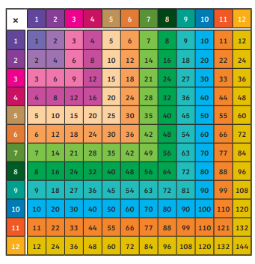  - Practise using a multiplication square to help you find x table facts  - Times table bowling game:   | Poppy English Learners  Read a little every day, this can be your reading book, BugClub or any book you have at home. Remember to write this in your reading record to earn your certificate!  Practise learning your 5 precision words for speedy reading and spelling. Look on the Poppy Class page for multi-sensory ideas to learn your words that are fun to do!  Have a go at writing these in a sentence- remember to use a capital letter, finger spaces and a full stop.  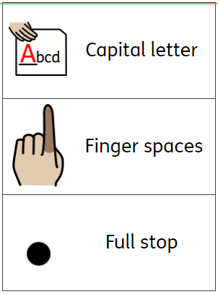  Handwriting-  Practise letter formation and capital letters-  See Poppy Class Page for parent guide.  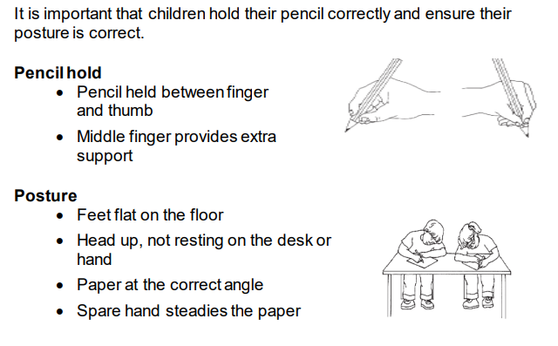
Please bring in your homework books in on Monday 25th March to share your work.
You can use your homework books for any other learning, trips etc. you have been doing!

