

Poppy Learners
Home Learning Term 5
Name: Maths English
Poppy Maths Learners  Will you be the Mathlete of the week?! https://login.mathletics.com  Speed up mental maths: https://www.topmarks.co.uk/maths-games/hit-the-button  Continue to practise 1:1 correspondence for counting amounts to 20 accurately  Practise comparing two numbers to 20 to identify which is bigger (toys/ lego/ steps/ jumps to support).  This term we will be focusing on Mass and Volume and Time.  1. Explore comparing which item is heavier or which item is lighter.  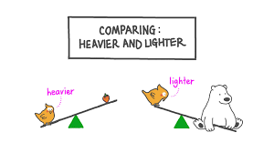  2. Fill different containers with water and use a measuring jug to work out which has the biggest capacity!  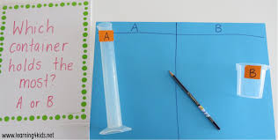  Challenge- Can you fill a container so it is half-full?  3. Practise telling the time- o’clock, half-past (30 mins past), quarter past(15 mins past), quarter to (45 mins past) | Poppy English Learners  Read a little every day, this can be your reading book, BugClub or any book you have at home. Remember to write this in your reading record to earn your certificate!  Please remember to bring in your reading record and reading book every day.  Practise learning your 5 precision words for speedy reading and spelling. Look on the Poppy Class page for multi-sensory ideas to learn your words that are fun to do!  Instructions  1. With an adult, have a go at following a recipe!    2. Can you draw, say or write steps to play a game or to give clues for a treasure hunt?  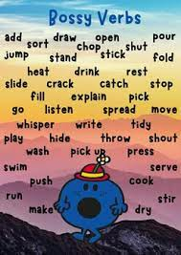  *Remember to use bossy verbs to make your instructions clear!
Please bring in your homework books in on Monday 20th May to share your work.
You can use your homework books for any other learning, trips etc. you have been doing!

