

Poppy Learners (KS2)
Home Learning Term 5
Name: Maths English
Poppy Maths Learners  We will continue to focus on multiplication and division, consolidating the 2,5 and 10 times tables and working with the 3, 4 and 8 x tables.  - Practise multiplication and division facts: https://www.topmarks.co.uk/maths-games/hit-the-button  - Learn the times table songs on Mathletics to help you remember them! https://login.mathletics.com  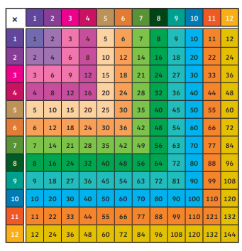  - Practise using a multiplication square to help you find multiplication and division facts  - Times table bowling game:   | Poppy English Learners  Read a little every day, this can be your reading book, BugClub or any book you have at home. Remember to write this in your reading record to earn your certificate!  Practise learning your 5 precision words for speedy reading and spelling. Look on the Poppy Class page for multi-sensory ideas to learn your words that are fun to do!  Instructions  1. With an adult, have a go at following a recipe!    2. Can you draw, say or write steps to play a game or to give clues for a treasure hunt?  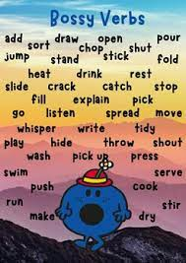  *Remember to use bossy verbs to make your instructions clear!
Please bring in your homework books in on Monday 20th May to share your work.
You can use your homework books for any other learning, trips etc. you have been doing!

