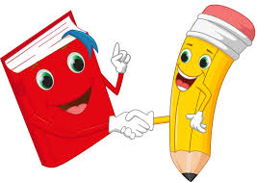
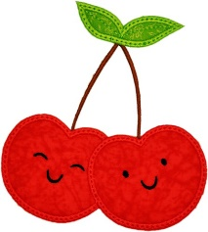
Cherry Class Home Learning
Term 1

The most important home learning you can do is to read. Make sure you are reading everyday, this can be your reading book, BugClub or any book you have at home.
Completing a short maths activity each day will also help your child to make good progress. This could be on Mathletics or online games such as Top Marks. There are further suggestions on the class page.
Maths  - Practise counting to 100.  - Practise counting in 2s, 5s and 10s.  - Order these numbers 17, 64, 56, 8  How many tens and ones do they have?  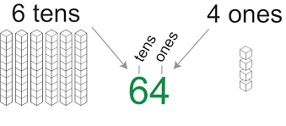  - Memorise the number pairs to 10  0-10, 1-9, 2-8, 3-7, 4-6, 5-5.  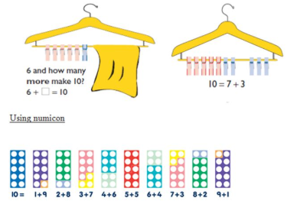  Use your fingers to help you.  Use these to find and remember number pairs to 20. | English  - Make sure you can spell all of the Year 1 words on their own and in sentences. (You can find these on the class page)  - Write a list of adjectives to describe yourself.  - Draw a picture and write sentences about yourself. When writing continue to practise the key writing skills of using capital letters, full stops and leaving spaces between words.  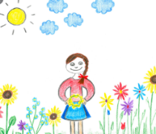
Science Living things and their habitats  - Draw a habitat you can find in West Malling (or local area), including the animals and plants that live there. You could write sentences about it too. | Geography- What a Wonderful World  - Choose your favourite animal and research where the animal lives in the world. Write about which continent it lives in and if it is from a hot or cold part of the world.
Choose 1 thing to do each week to help support learning in class.
Please bring in your homework books in on Monday 17th October to share your work.
Please use your homework books for any other English or Maths work you have been doing.

