

Poppy Class
Home Learning Term 2

Maths  Completing a short maths activity each day will also help you to make good progress.  This could be on Mathletics or online games such as Top Marks…  (See links on the Poppy Class page)  …Or by simply practising writing your numbers in numerals and words  *See your homework book for a weekly activity suggestion  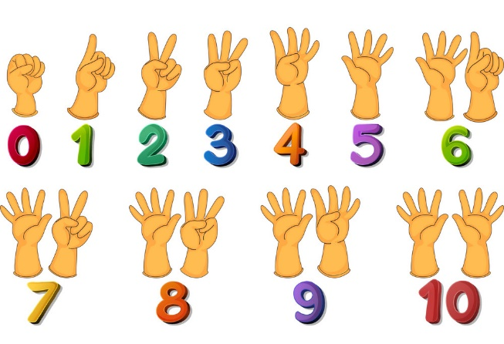 | English  The most important home learning you can do is to practise your 5 precision reading words every day.  Flash cards will be sent home every week.  There are some great ideas for fun multi-sensory activities to help learn to read and remember your words on the Poppy Class page.  Make sure you are reading a little everyday, this can be your reading book, BugClub or any book you have at home. Remember to write this in your reading record to earn your reading bear and certificate!  10 reads = reading bear  20 reads = bronze certificate  40 reads = silver certificate  60 reads = gold certificate
RE- Incarnation- Why does Christmas matter to Christians  Make your own nativity scene with characters  https://www.pinterest.co.uk/pin/52495151884375302/ | Topic- The history of West Malling  - What can you find out about St. Leonard’s Tower?  - Look out for the blue plaques that show famous people who have lived in or visited West Malling (Including ‘The Beatles’!) https://www.visitkent.co.uk/malling-blue-plaques/

Please bring in your homework books in on Monday 12th December to share your work.
You can use your homework books for any other learning, outings etc!

