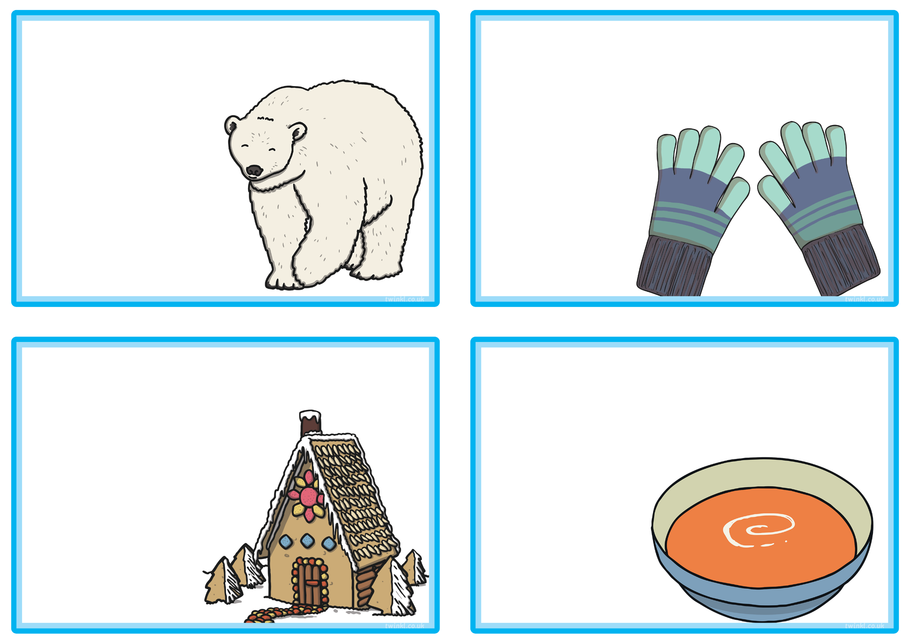
There were 18 baby polar bears in a cave. The parents want to put them into pairs. How many pairs will there be?
Winter Multiplication and Division

Winter Multiplication and Division

Winter Multiplication and Division

Winter Multiplication and Division

Each flavour of soup takes 2 hours to make. How long will it take to make 3 different flavours?
Tamara was making a gingerbread house. She had 20 sweets to share between the four sides of the house. How many sweets could she use on each side of the house?
There are 15 mixed up gloves in a pile. How many pairs could you make? How many would be left over?


