
West Malling C. E. Primary School
Daisy Room
Curriculum Newsletter Term 1

Dear Parents and Carers,
Welcome back to a new school year, in which many routines are a bit different from usual!
As you know, we will be spending all of our day in our McGinty bubble, which means that sadly, for the time being, we will not be joining our inclusion classes in the afternoons. Here are some details of all the subjects we will be learning in Daisy Room this term.
English
Our Power of Reading book this term is Here We Are: Notes for Living on Planet Earth by Oliver Jeffers.



The shared reading and writing activities linked to this book are planned to support the children to raise questions, express concerns, build resilience and reconnect with each other and the wider world around them.
In addition we will have daily guided reading sessions in which the children will read a range of other texts and complete reading related activities, supported by an adult in a small group or individually. On Fridays, the children will select a few books to bring home to share with you throughout the following week. These should be returned each Friday so that your child can choose some different books. These returned books will be wiped down and set aside until the following week to prevent the risk of infection. Home reading books will only be changed on Fridays and should not be brought back to school on other days.

General Information

We attach our term 1 timetable, so that you can see when each subject will be taught. It is important to note that our PE lesson will be on Thursdays. To help reduce the risk of infection, children will not be changing in school so PE kits should be kept at home. Please send your child your child into school dressed in their PE kit every Thursday.
Our Speech and Language therapist Mrs Katherine Robertson will be working with us each Tuesday. Although at the moment she will be unable to come into school, she will carry out some video therapy sessions with children, supported by school staff.
After such disruption to schooling in the past 6 months, this term will involve a lot of consolidation and assessment to help us support each child in the way that is best for them. Each Friday we will email you with some details of the work that has been done that week, so that you can talk with your child about their learning. We will include some suggestions of activities you may want to do at home as well as a list of spellings that will be tested on Monday morning. This term we will be revising phonic sounds previously taught: if your child needs further challenge, please help them practise some tricky words from the KS1 or KS2 spelling lists.
As always, please feel free to contact us if you have any questions or concerns by emailing daisyteacher@west-malling.kent.sch.uk.

Mrs Ray (Mon, Tues, Wed)
Miss Bled (Thurs, Fri)
Miss Crann (Mon, Tues, Wed)
Miss Chapman (Thurs, Fri)
Mrs Denby (all week)
Mr Huggins (all week)

Maths

This term we will be focussing on:

Number and Place value
- Reading and writing numbers in numerals and words
- Counting forwards and backwards in different steps
- Partitioning numbers
- Comparing and ordering numbers
Addition and Subtraction
- Adding and subtracting using different resources
- Practising quick recall of number bonds and finding related facts
- The relationship between addition and subtraction
- Solving missing number problems
Time
- Telling the time on an analogue clock
- Knowing the days of the week and months of the year
- Compare times using the correct vocabulary (eg earlier, later, yesterday, today, tomorrow)

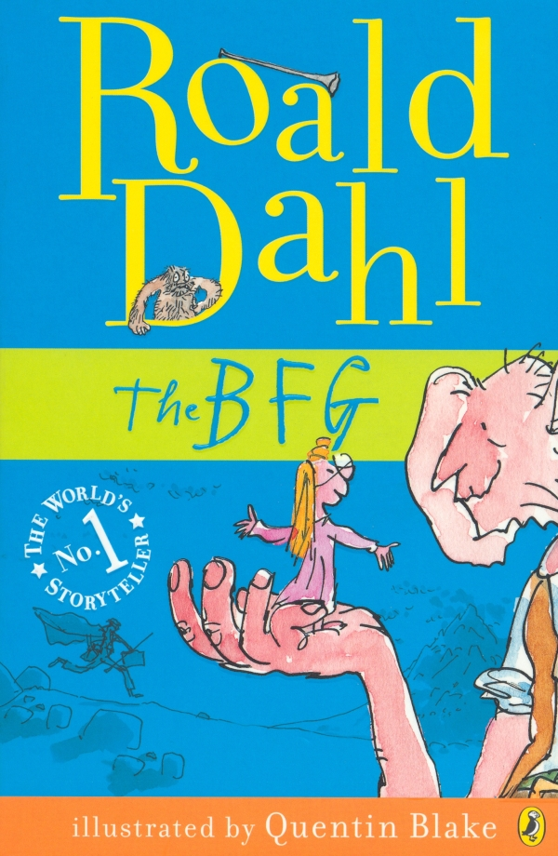
Topic
This term our History topic will be Ancient Persia and Ancient Greece. We will learn about the Persian Empire, aspects of life in the Greek city states (including Greek Gods and Homer’s story of The Iliad) and the wars between Persia and Greece.
In our History lessons this term we will meet several unfamiliar, multisyllabic words, and so we will practise strategies to help us learn and say tricky words.

Science
Our Science topic this term will be Forces and Magnets We will learn what force means and explore how magnets are a force without touching it. As this will be taught in the language centre, the pre-teaching and rehearsing of key concepts and vocabulary will now be embedded in each lesson, rather than in separate language groups.



