L.I: To begin to learn some facts about the Indus River.
Indus River
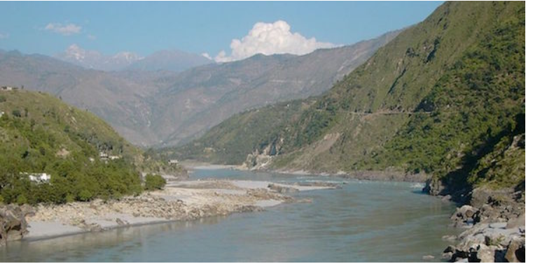

Continent: ______________
Length: ________________
Country where the source of the river is:
_______________________________________
Place where the mouth/estuary/delta is:
_______________________________________
Ocean/sea that the river flows into:
_______________________________________
Any other information you can find:
__________________________________________________________________________________________________________________________________________

