Weighing fruits

Sheet 1

© Hamilton Trust

Answer these questions:
- Which fruit is the heaviest?
- Which fruit is the lightest?
- Which two fruits weigh the same?
- Which fruit weighs the same as 2 bricks?
- Which fruit is the second heaviest?
- Which fruit weighs the same as 3 bricks?

Challenge

Which fruit weighs the same as a kiwi and 3 strawberries?

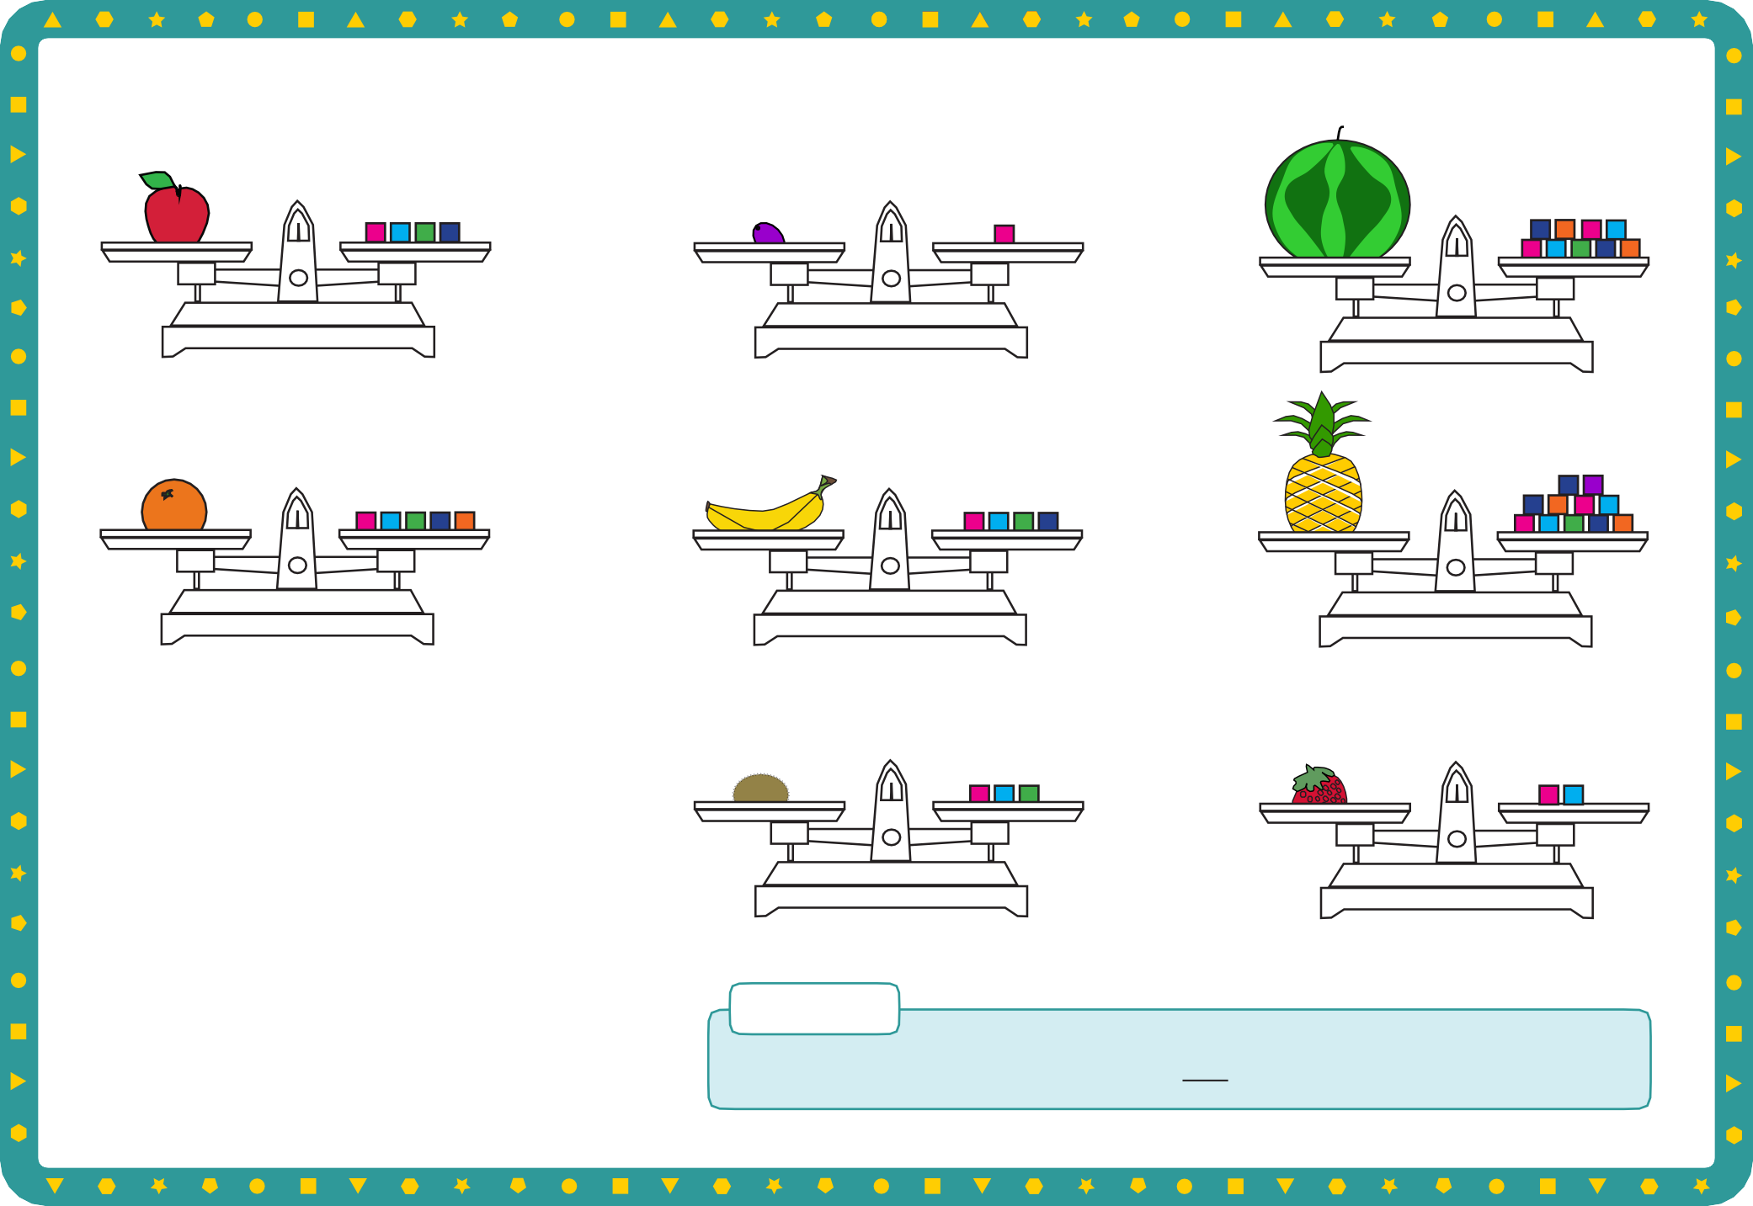
© Hamilton Trust practice_meas-data_12492_day2

An apple weighs about 100 grams. A bag of sugar weighs 1 kilogram.

Weight

Sheet 2
SUGAR
1 kg

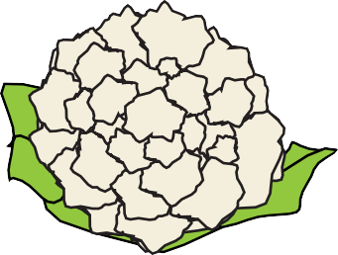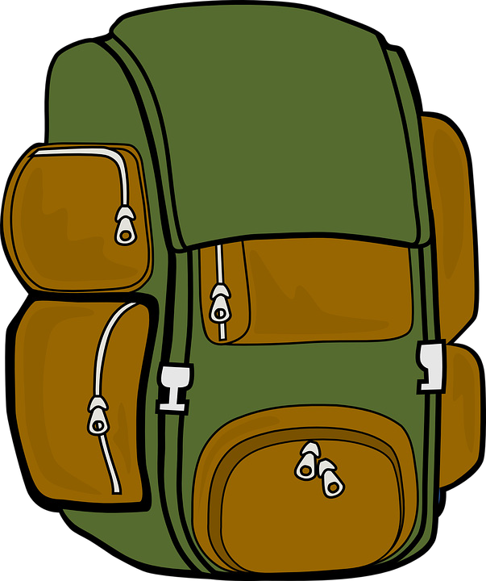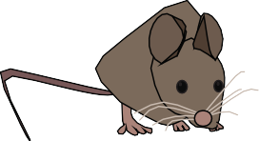

© Hamilton Trust

Draw the things you think will weigh less than100 grams | Draw the things that might weigh about1 kilogram | Draw the things you think will weigh more than 1 kilogram

© Hamilton Trust practice_meas-data_12492_day2

How many 100g weights balance each item?
Weight
Sheet 3

Write the number of weights. Count in steps of 100 to find the weight in grams. The first one is done for you.

100g 100g

100g 100g

100g 100g 100g 100g

100g 100g

100g 100g

100g

100g

2 weights 200 grams weights grams weights grams

© Hamilton Trust

100g 100g

POTATOES
100g 100g

100g 100g

100g 100g

100g 100g

100g

100g 100g

100g 100g

100g

100g

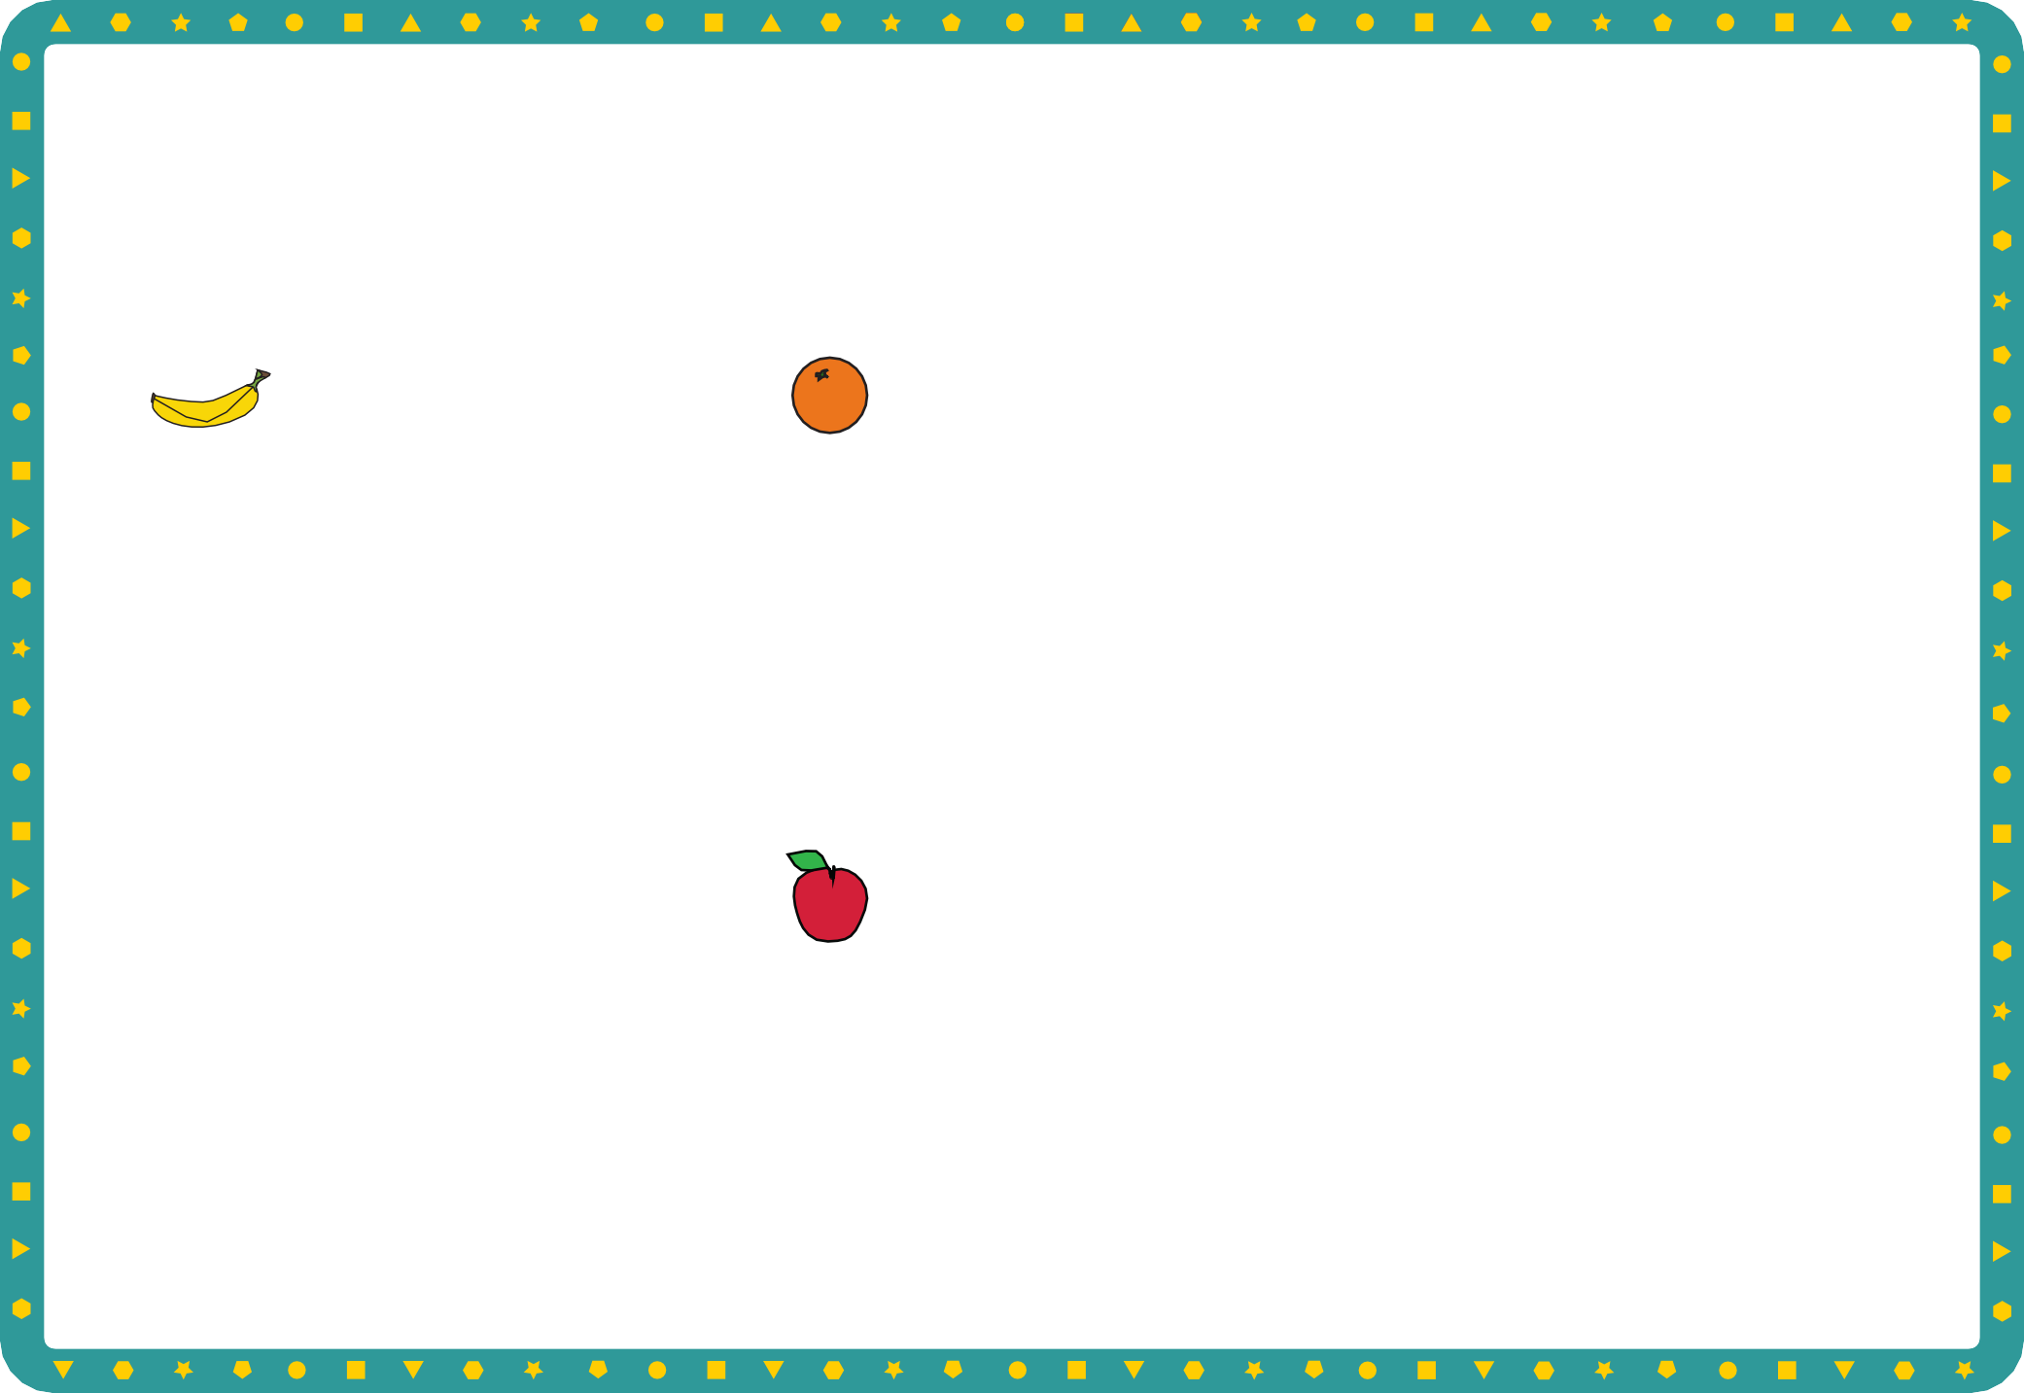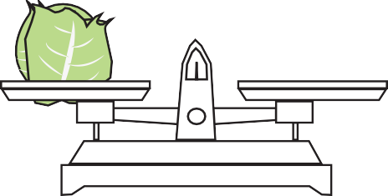

weights grams weights grams weights grams

© Hamilton Trust practice_meas-data_12492_day2


Weight

Sheet 4
Draw each item weighed in the correct place in the table below.

Lighter than 500 grams | Heavier than 500 grams
© Hamilt | on Trust

Challenge
Write some items that make the same weight, e.g. 8 apples = 1 cabbage.

© Hamilton Trust practice_meas-data_12492_day2

