How can we describe water?
Match these pictures of water with the words given – there is no right or wrong answer and you can use the words more than once. Draw a straight line to match them.
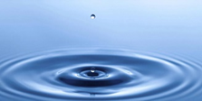 |  | cleansing  dangerous
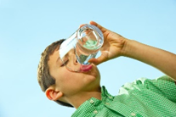 |  | reflective
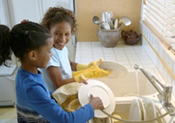 |  | life-giving
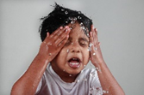 |  | still
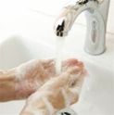 |  | like a mirror
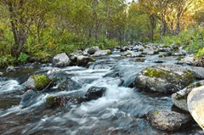 |  | refreshing  powerful
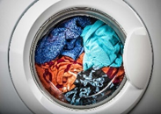 |  | beautiful  thirst-quenching
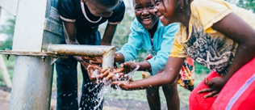 |  | flowing
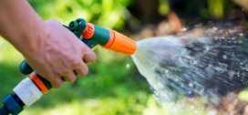 |  | soothing

