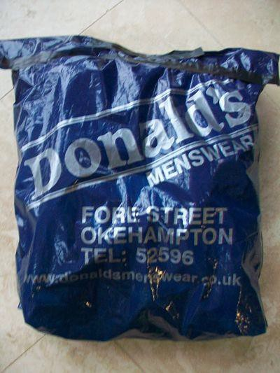
- Stuff a strong carrier bag with scrunched up scrap paper and squeeze most of the air out.
- Fold over the top and tape it
up with strong tape.
Make a River Canal

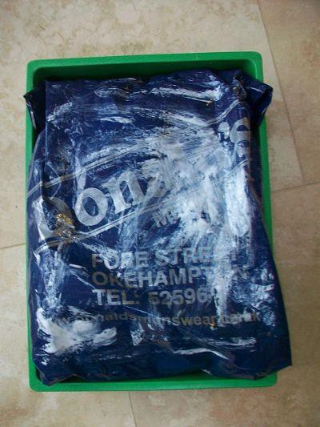© Original resource copyright Hamilton Trust, who give permission for it to be adapted as wished by individual users.
3. Put the bag inside your tray and paint the top with diluted PVA glue.
We refer you to our warning, at the foot of the block overview, about links to other websites.

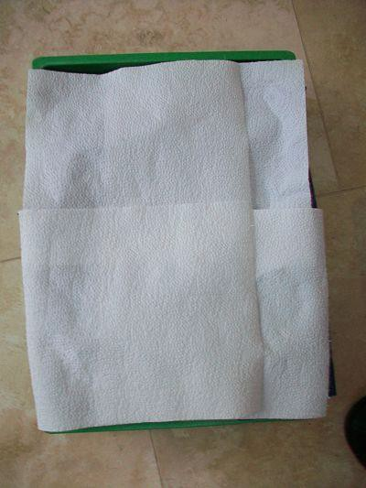
- Lay 4 sheets of kitchen paper over the wet PVA and gently press them down.
- Lift up the dry overlapping sections
and paint PVA mixture under them.

- Press down so the kitchen paper is well stuck to the bag

- Make a “valley” down the centre line of the tray by pressing down with the edge of your hand.

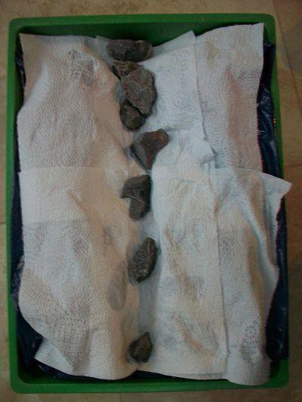

- Brush a little more PVA into the
valley so it is moist here.
- Place stones along the line of the valley to help mould the moist paper into shape. Put more stones or heavier ones at one end to give your valley a slight downward slope.
- Leave for a little while to dry and set into shape.

To plant your crop (cress)
- Put a new layer of kitchen paper over your river valley
- Spray it with water and gently press down the wet paper so it takes the shape of the valley
- 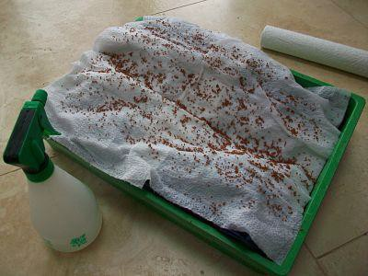Now sprinkle the cress seeds over the whole river valley and surrounding desert. Try to get them as evenly distributed as possible
- You will find they fall down to the river bed and do not stick very well so try spraying them with a little more water and very gently spreading them up the slopes with your finger.

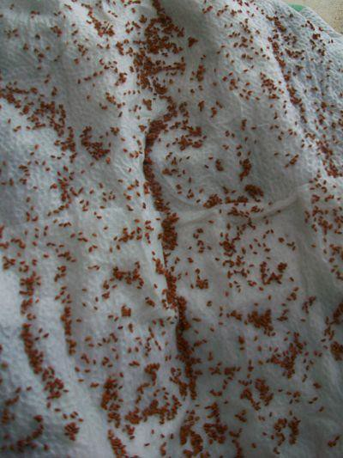
Lower end of the river
- Once the seeds are spread out as evenly as you can, Spray once more gently over the whole valley and desert –this will allow your seeds to begin to grow (germinate)
- From now on you will only water your seeds by very gently pouring water to the top end of the valley. Trickle about 100ml once a day. The water should flow down the river just as it flows through The Indus.
Top end of the river

