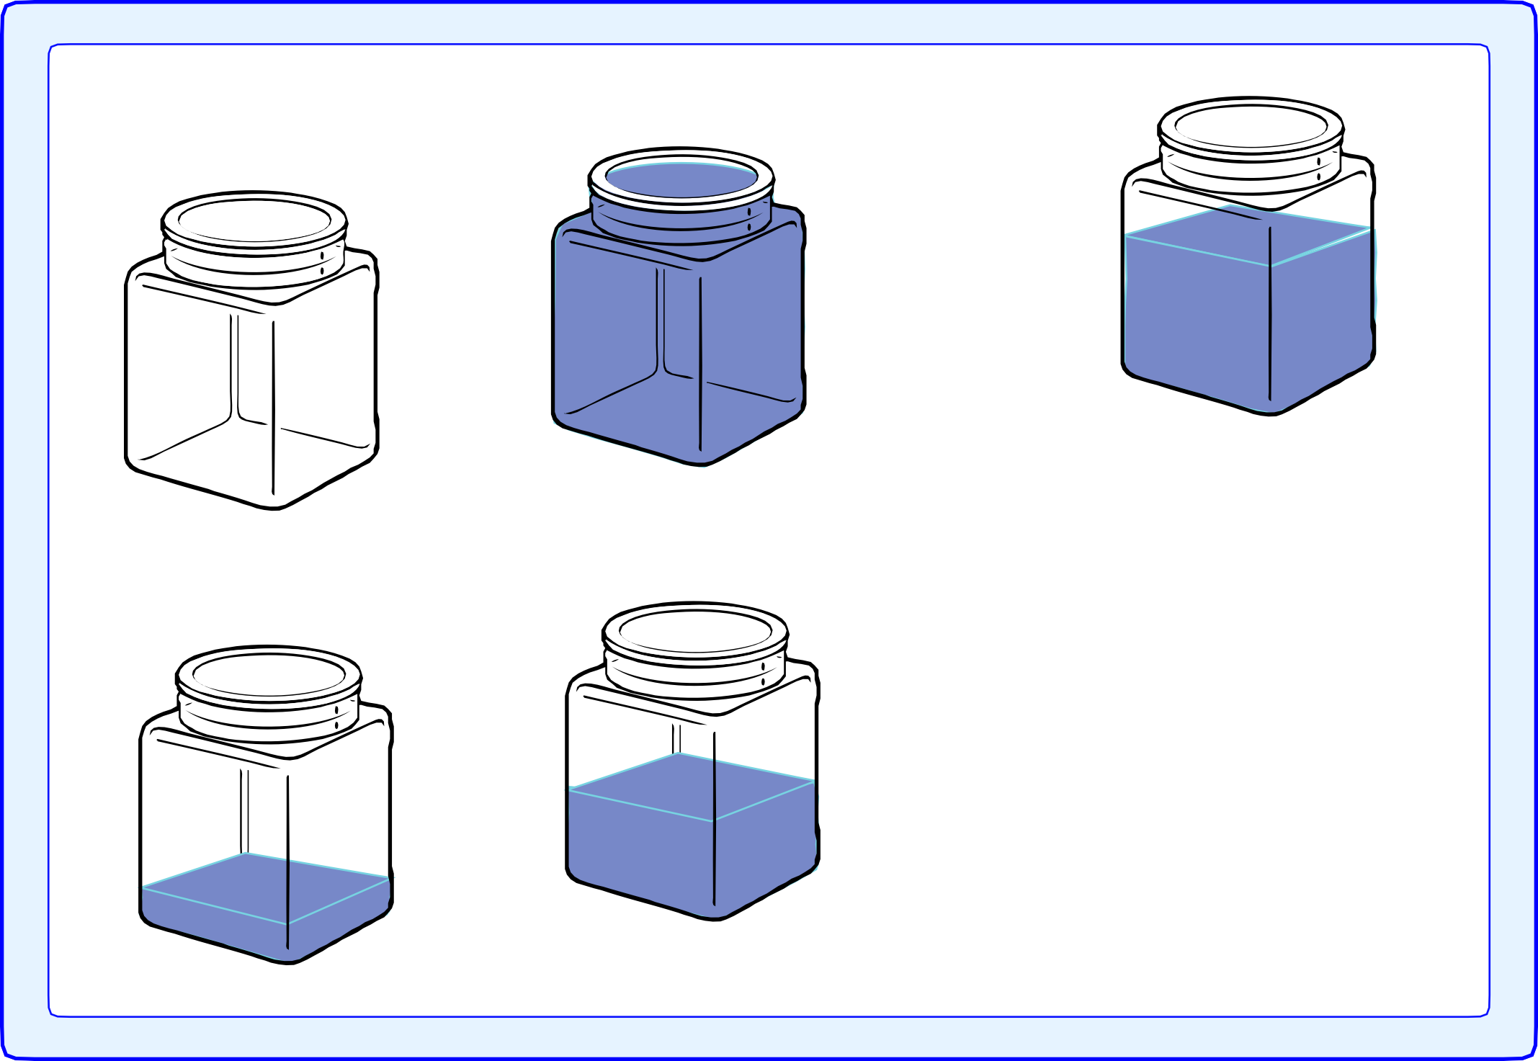

30
27
29

Empty and full

empty nearly empty
half full nearly full full

© Hamilton Trust resources_meas-data_12508
50

Comparing capacities

vase

30

Draw a line from each container to show many cupfuls it holds.
27
29

Write the containers in order from the least capacity to the greatest capacity.

glass
teapot

bowl

milk jug

bucket
4 cupfuls
6 cupfuls
8 cupfuls
2 cupfuls
1 cupful
3 cupfuls

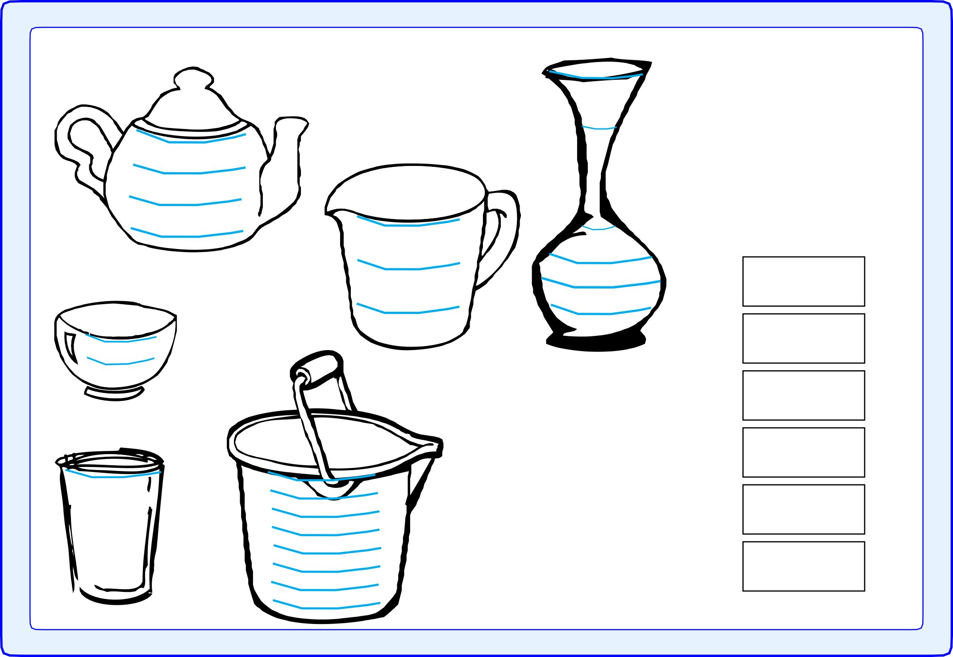

© Hamilton Trust resources_meas-data_12508
50

30
27
29

Results

Containers | Estimate | Measure

Block Graph of Results
10
9
8
Number of cups
7
6
5
4
3
2
1

Name of container
50

