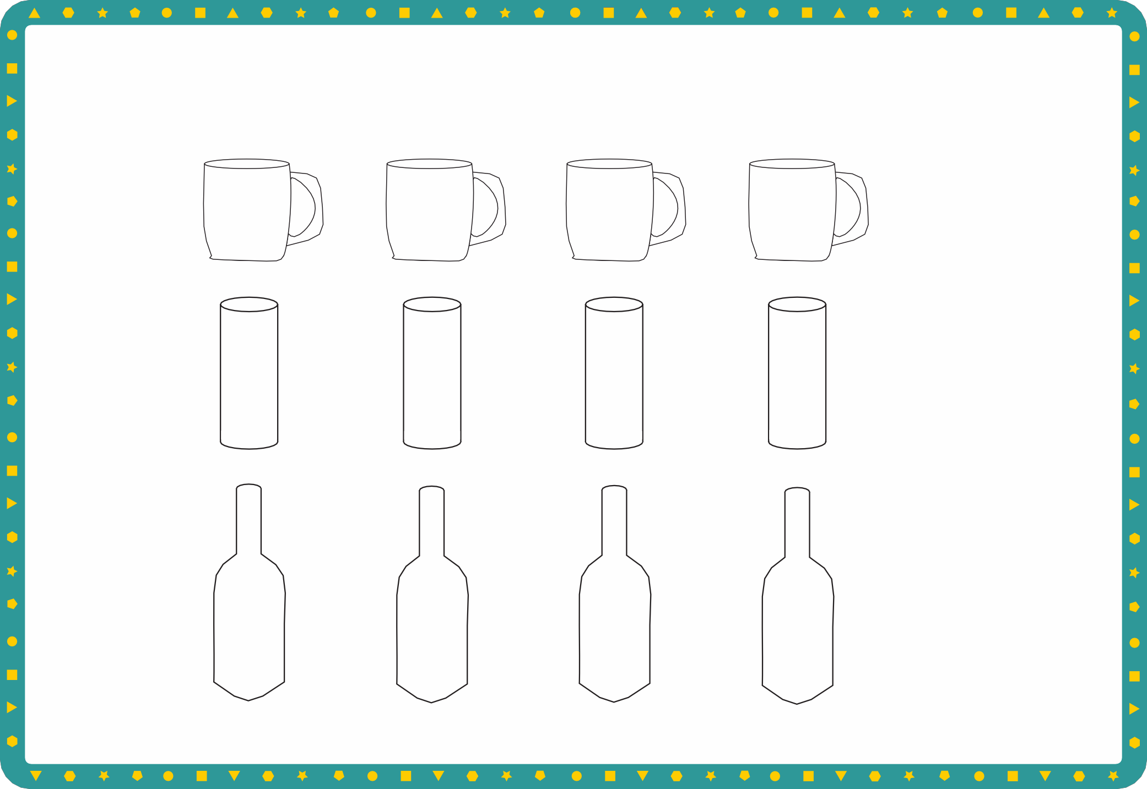
Capacity

Sheet 1
Draw a line to show how much water would be in each container.

Full Nearly full Half full Nearly empty

Full Nearly full Half full Nearly empty

Full Nearly full Half full Nearly empty
© Hamilton Trust day1


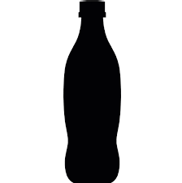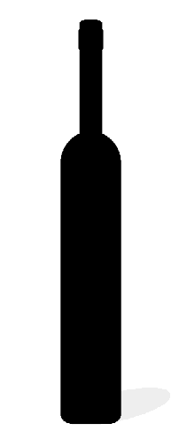Block graph
3
cups
9
cups
6
cups
C

Sheet 2

10

9
8
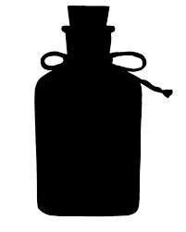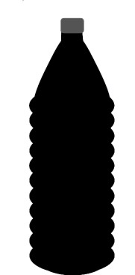A B 7
6
cups
8
cups
4
cups
Number of cups
6
5
4
3
2
D E F
1

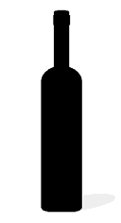
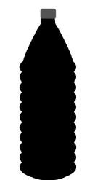C D
E
F
Challenge
0
- Which bottle holds the most water?
- Which bottle holds the least water?
- Which two bottles hold the same amount of water?
- Which bottle contains 5 more cups than bottle F?
- Which bottle contains double the amount of bottle F?
- Which bottle contains double the amount of bottle A?
A

B

Bottles
© Hamilton Trust day1

