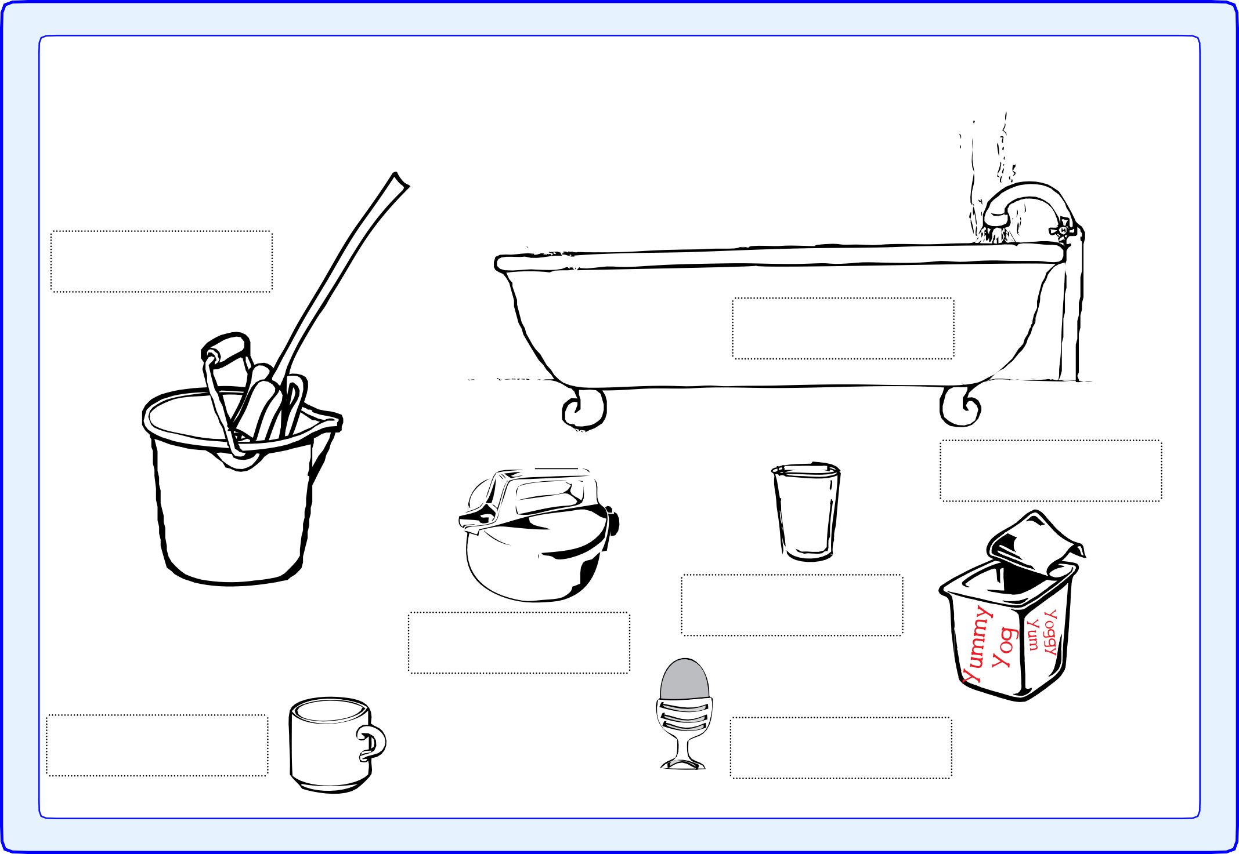

30
27
29

More or less than a litre

Write more under a container if you think it holds more than a litre, and less if you think it holds less than a litre.

bucket

bath

yoghurt container

glass
kettle

mug egg cup

© Hamilton Trust resources_meas-data_12508
50

