Comparing capacities

Sheet 1

Which container has the biggest capacity? Tick the one you think holds the most water.

washing
m up
i
O

Orange
SQUASH

No added sugar

in

Circle the containers that would hold more
than a glass of water.

- Circle the containers that would hold less
than a school water bottle.

Washing up

Orange
SQUASH

No added sugar

Orange
SQUASH

No added sugar

Yoghurt

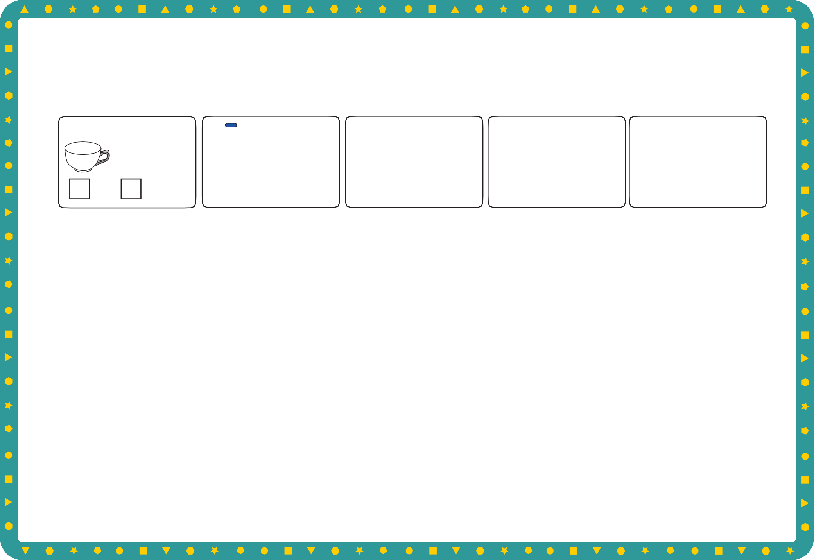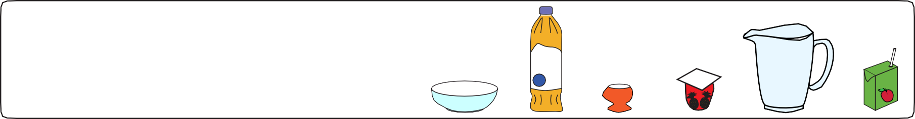

Draw containers that would hold more water than this watering can.

© Hamilton Trust practice_meas-data_12508 _day2

Container capacity

Sheet 2
Remember the jug and bottle that held 1 litre...

Sort the containers under these two headings by writing their letters in the correct column.

A
More than 1 litre Less than 1 litre

I
egg

C B E J

H
F

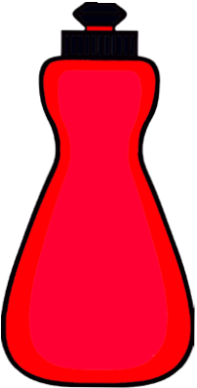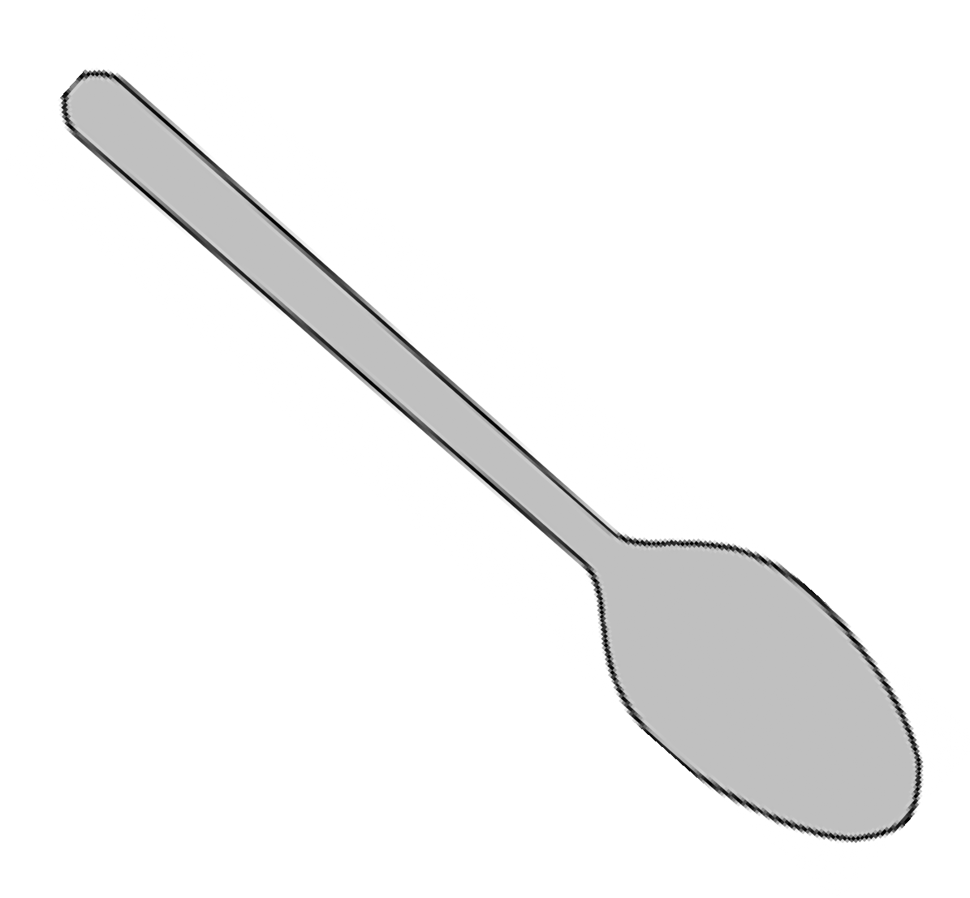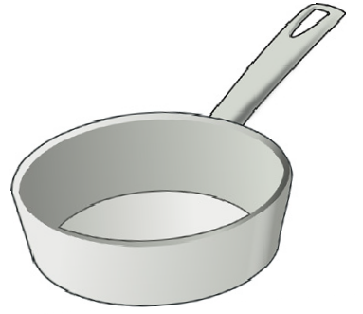

O L

M

N
K
P
D G

Challenge
Choose four containers and write the number of yoghurt pots you think each would hold.

© Hamilton Trust practice_meas-data_12508_day2

Pictogram

Sheet 1
Create a pictogram to show how much water each of the containers holds.

2 cups of water 5 cups of water

Bubbles

Orange
SQUASH
7 cups of water
1 cup of water



No added sugar

4 cups of water 8 cups of water

Container | Number of cups of water


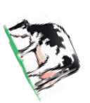Challenge
- Which container holds the most water?
- Which container holds the least water?
- Which container holds 1 more cup than the school water bottle?
- How many more cups does the milk carton hold than the washing up bottle?

© Hamilton Trust practice_meas-data_12508 _day3

