Pictogram

Sheet 1
Create a pictogram to show how much water each of the containers holds.

2 cups of water 5 cups of water

Bubbles

Orange
SQUASH
7 cups of water
1 cup of water

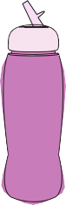

No added sugar

4 cups of water 8 cups of water

Container | Number of cups of water
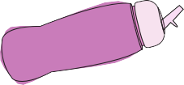

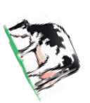Challenge
- Which container holds the most water?
- Which container holds the least water?
- Which container holds 1 more cup than the school water bottle?
- How many more cups does the milk carton hold than the washing up bottle?

© Hamilton Trust practice_meas-data_12508 _day3

Capacity

Sheet 2

- Draw a circle around the containers that you think hold less than 1
2
litre.

- Draw a square next to those which hold more than 1 litre.

egg

Water

Hand soap

Milk
OLIVE
OIL

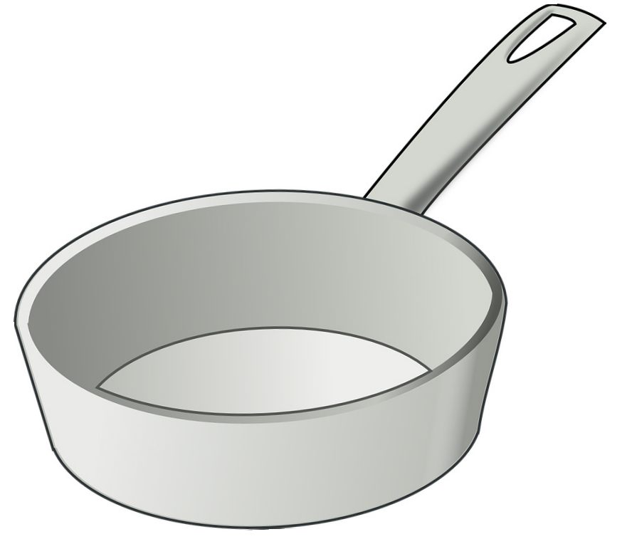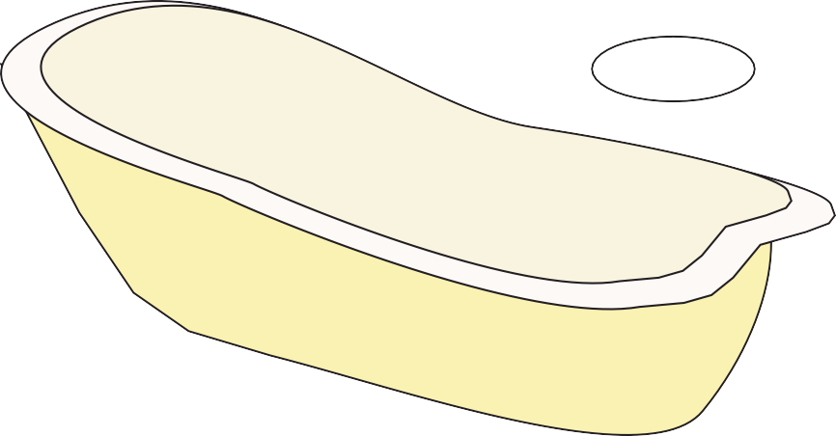

- Write the letters A to L beside the containers so that you order them from the one that holds the least (A), to the one that holds the most (L).
- Can you estimate which three containers together might fill a 1 litre container?

Challenge
Create a paper container that holds exactly half a litre.

© Hamilton Trust practice_meas-data_12508_day3

