The Water Cycle

-1f- twinkl.co.uk *

-------
Label the diagram of the water cycle using the words below:

rivers and streams precipitation runoff groundwater sea
wind Sun
evaporation condensation
transpiration

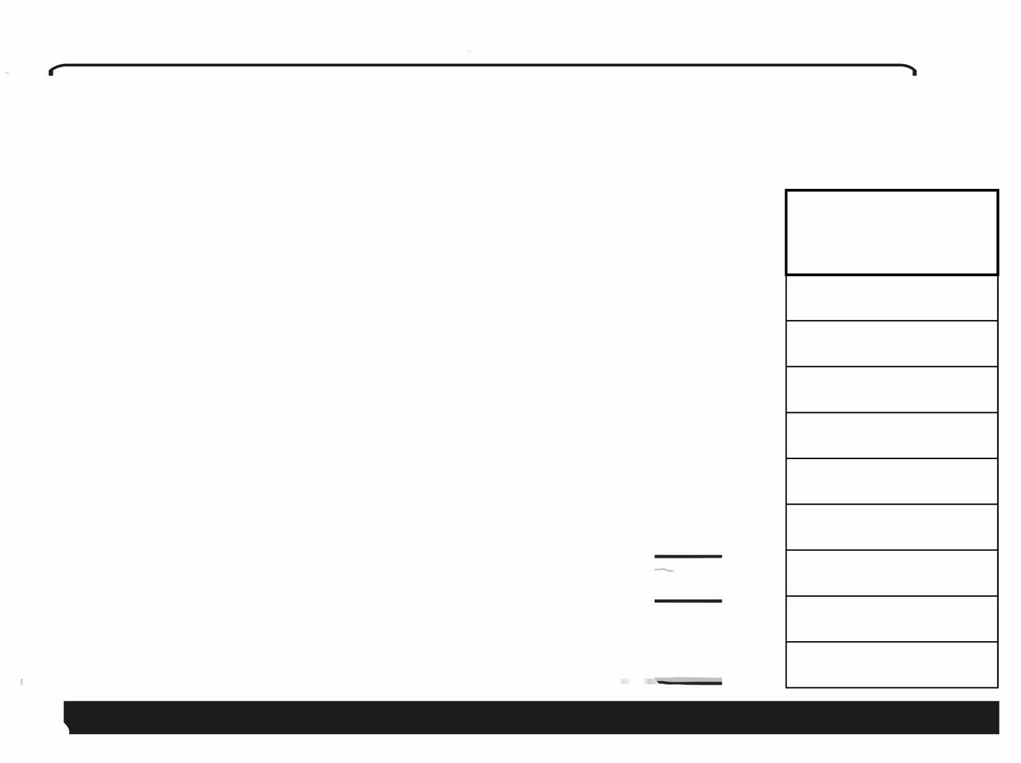
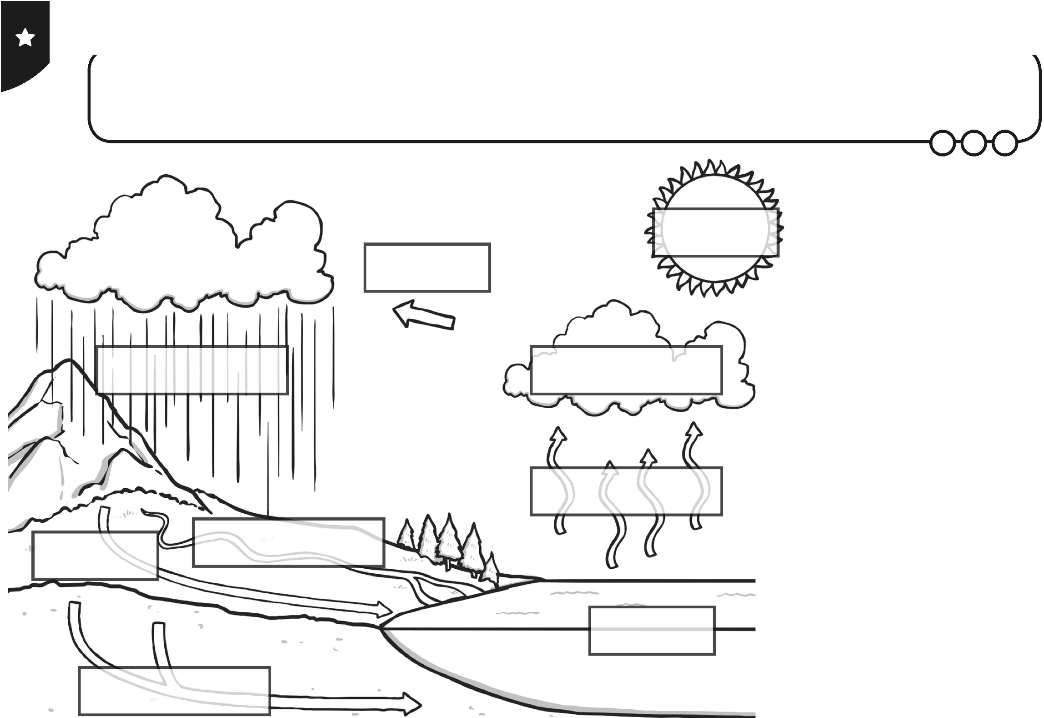
plan it Geography I Year 4 I Water I The Water Cycle I Lesson 2

The Water Cycle

Label the diagram of the water cycle.

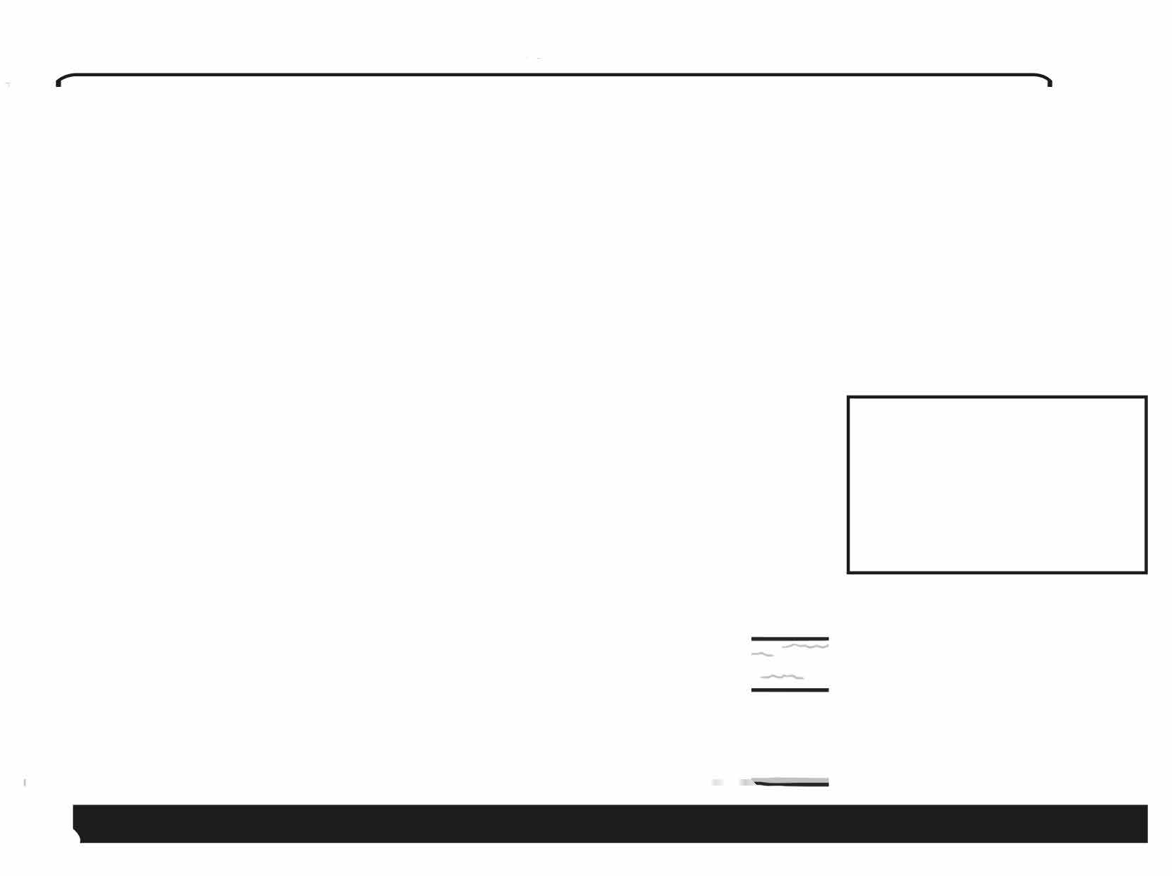
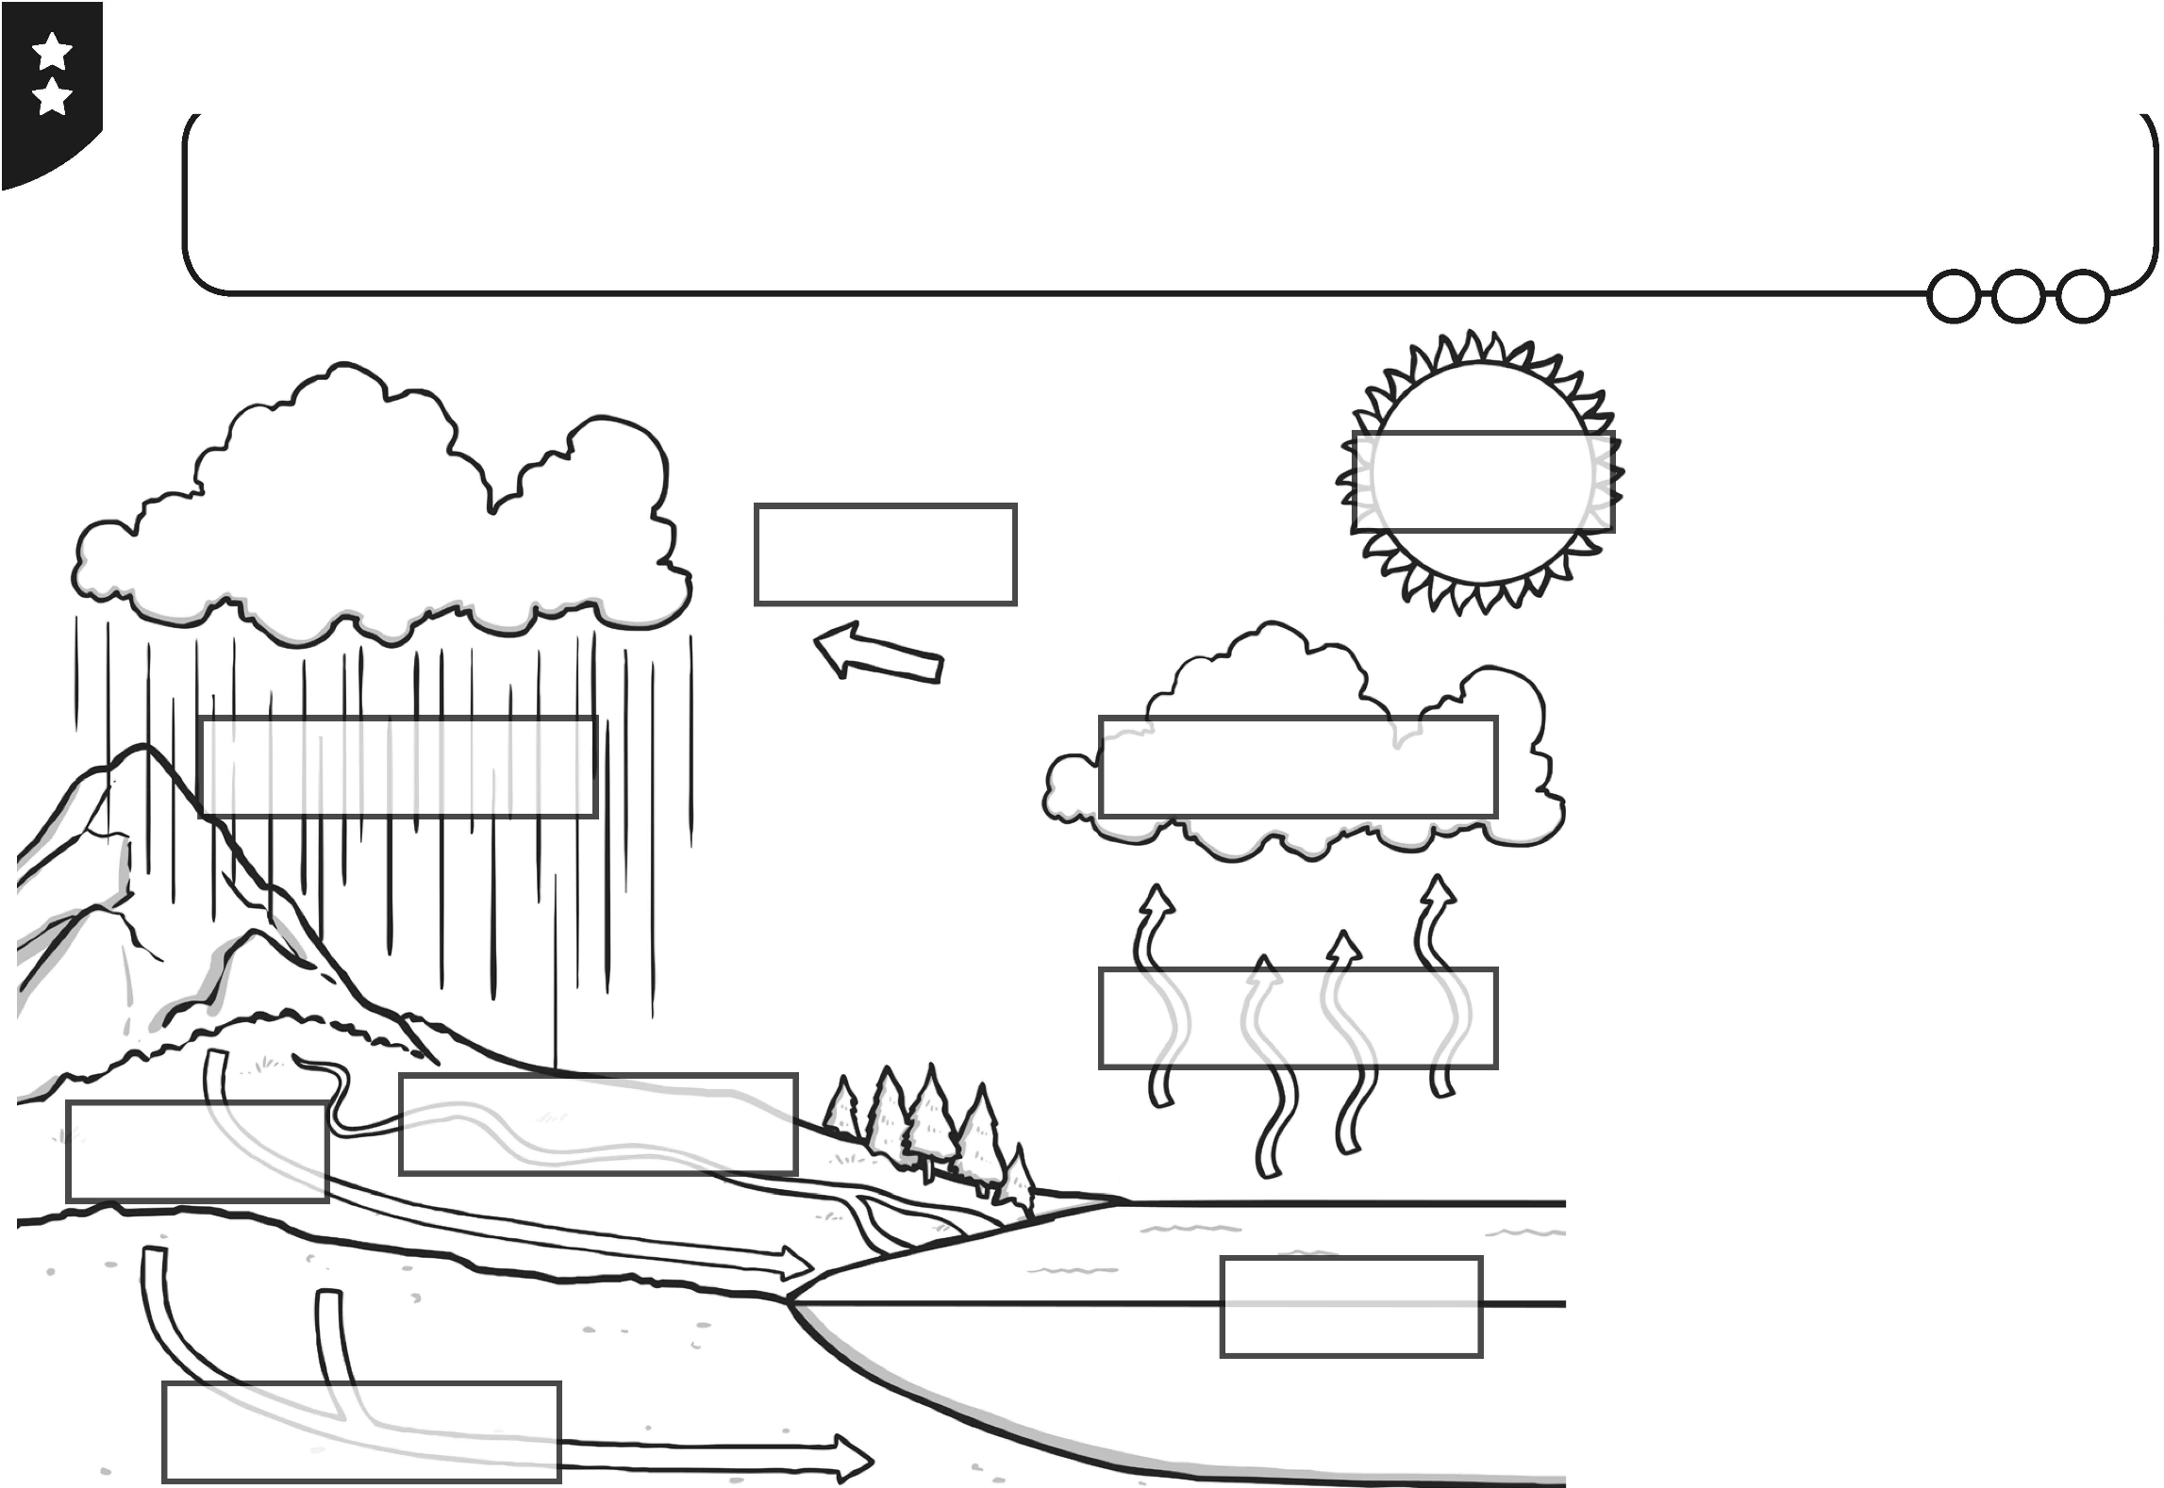
1m1f- twinkl.co.ulk *

plan it Geography I Year 4 I Water I The Water Cycle I Lesson 2



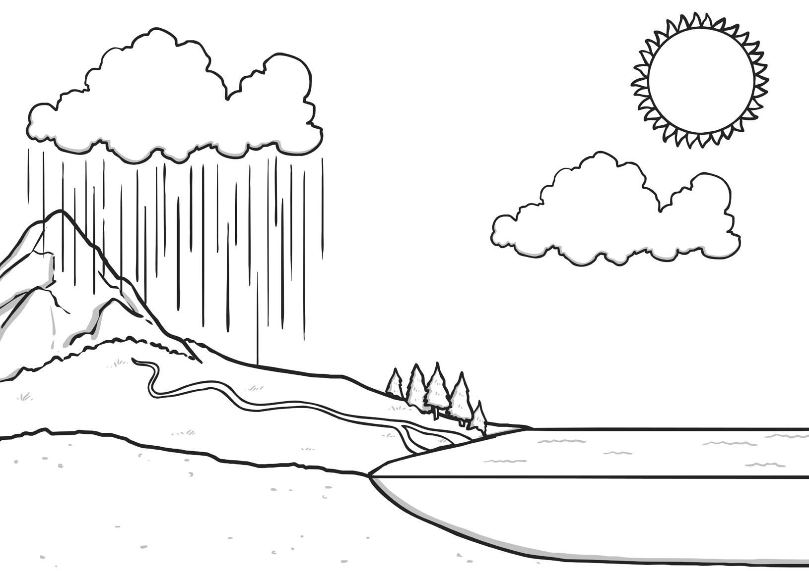

The Water Cycle




Label the diagram of the water cycle and add arrows.

Geography | Year 4 | Water | The Water Cycle | Lesson 2

