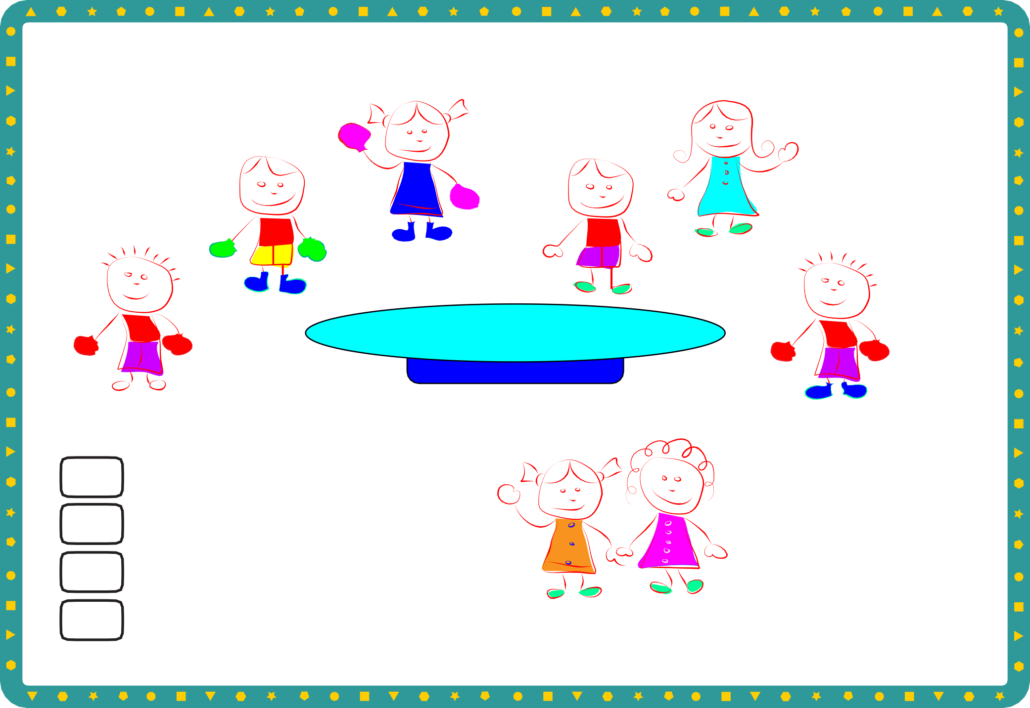
Counting in 2s
Sheet 1

I counted...
eyes
hands with gloves blue shoes
green shoes

© Hamilton Trust practice_frac-mult_12572 _day1

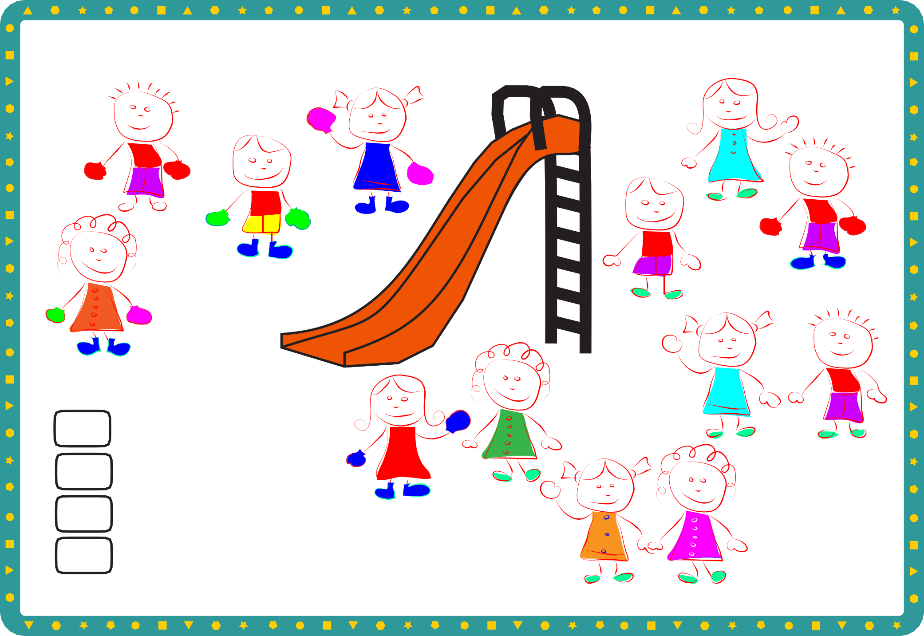
Counting in 2s
Sheet 2

I counted...
eyes
hands with gloves blue shoes
green shoes

© Hamilton Trust practice_frac-mult_12572 _day1



