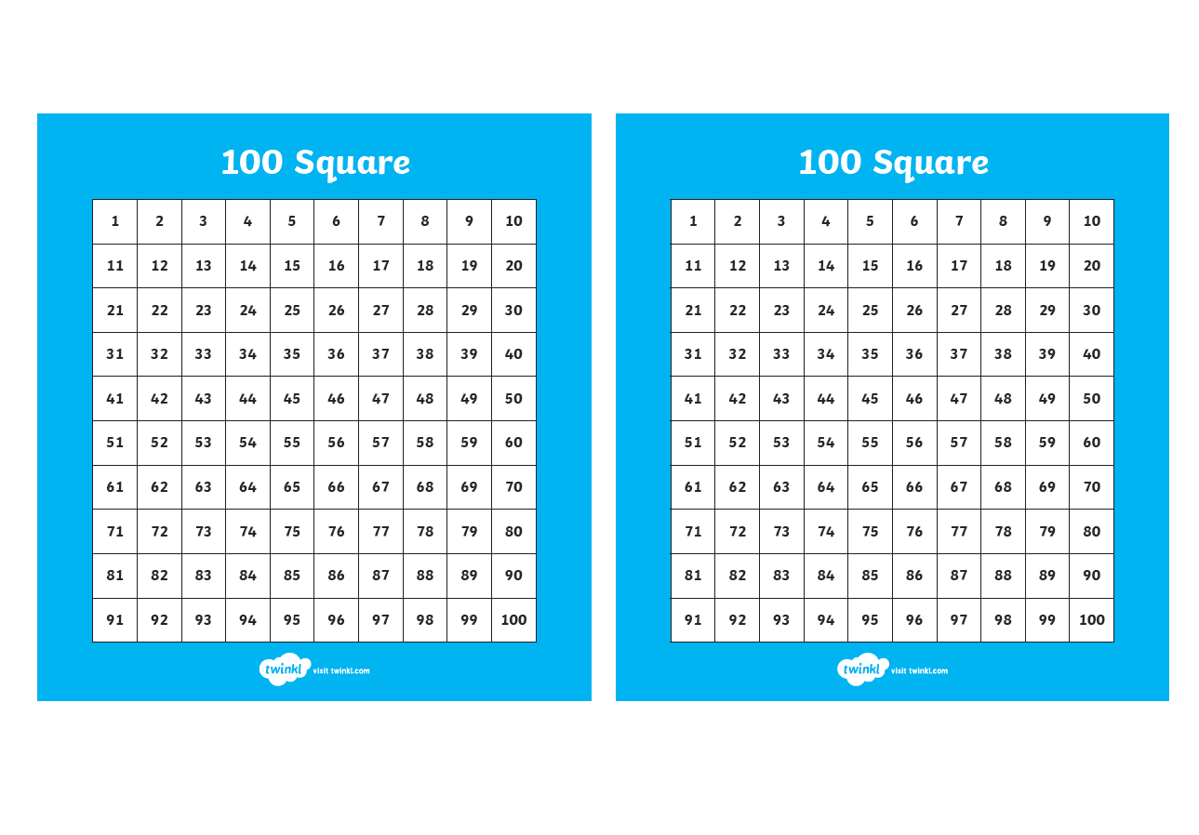

30
27
29

0-100 beaded lines

0 10
20 30
40 50
60 70
80 90
100

0 10
20 30
40 50
60 70
80 90
100

0 10
20 30
40 50
60 70
80 90
100

0 10
20 30
40 50
60 70
80 90
100

0 10
50
20 30
40 50
60 70
80 90
100

0 10 20 30 40 50
60 70 80
90 100



0-30 beaded lines

0 10 20 30
74

0 10 20 30

0 10 20 30
66

0 10 20 30

0 10 20 30
27
© Hamilton Trust.
29

Explore more Hamilton Trust Learning Materials at https://wrht.org.uk/hamilton
30
resources_mult-div_23556



0-50 beaded lines

0 10 20 30 40 50
74

0 10 20 30 40 50

0 10 20 30 40 50
66

0 10 20 30 40 50

0 10 20 30 40 50

0 10 20 30 40 50
27

© Hamilton Trust.
Explore more Hamilton Trust Learning Materials at https://wrht.org.uk/hamilton

resources_mult-div_23556
29
30



