Fish doubles

Sheet 1

2 + 2 =
 | + |  | =

 | + |  | =

© Hamilton Trust
 | + |  | =

 | + |  | =

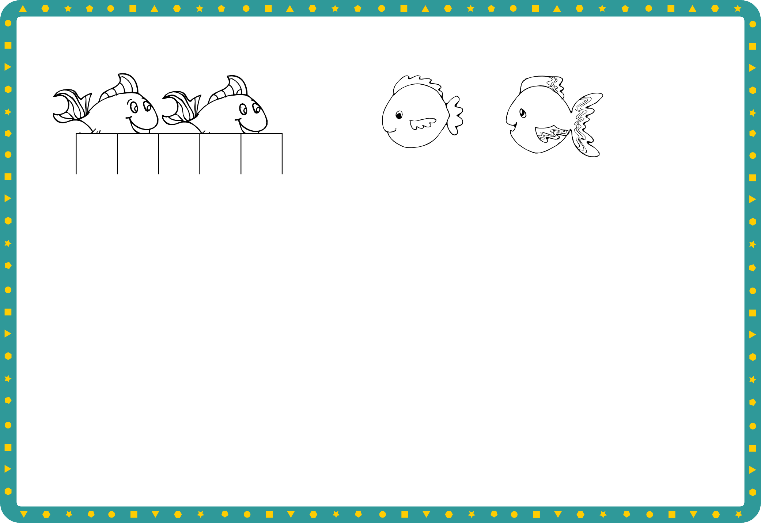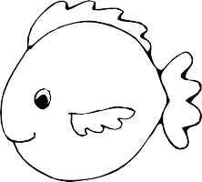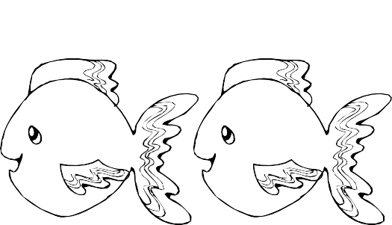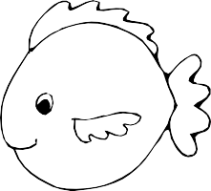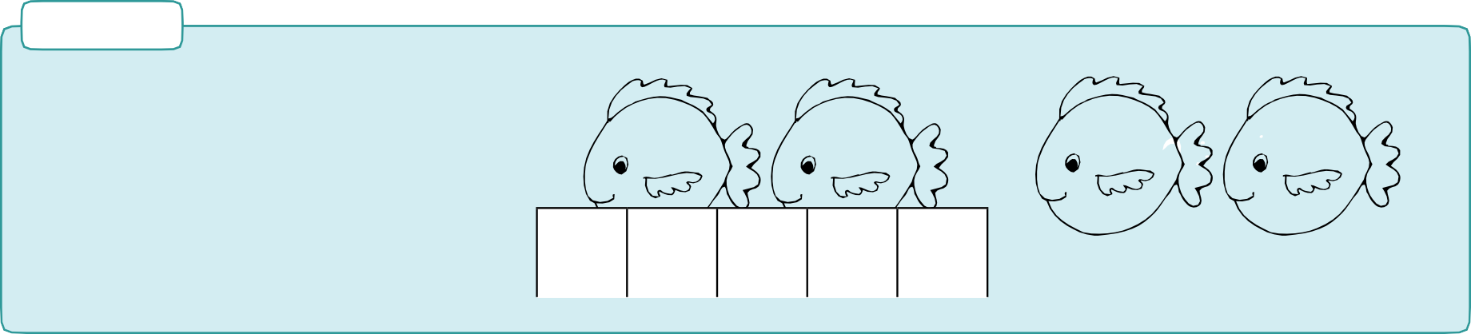

Challenge
 | + |  | =

DDrraaww atwndo cmooloreurdyifofuerreonwtnfidshiffdeoreunbtlerse. ctangle on squared paper for each ratio. Write a number sentence for each.

+ =
 | + |  | =

© Hamilton Trust practice_frac-mult_12572_day3

Multiples of 3

Sheet 2

Shade in multiples of 3 on this grid:

1 | 2 | 3 | 4 | 5 | 6 | 7 | 8 | 9 | 10
11 | 12 | 13 | 14 | 15 | 16 | 17 | 18 | 19 | 20
21 | 22 | 23 | 24 | 25 | 26 | 27 | 28 | 29 | 30
31 | 32 | 33 | 34 | 35 | 36 | 37 | 38 | 39 | 40
41 | 42 | 43 | 44 | 45 | 46 | 47 | 48 | 49 | 50

Now shade them on this grid:

1 | 2 | 3 | 4 | 5 | 6 | 7 | 8 | 9
10 | 11 | 12 | 13 | 14 | 15 | 16 | 17 | 18
19 | 20 | 21 | 22 | 23 | 24 | 25 | 26 | 27
28 | 29 | 30 | 31 | 32 | 33 | 34 | 35 | 36
37 | 38 | 39 | 40 | 41 | 41 | 43 | 44 | 45

Why are the patterns different on the two grids? Which of these numbers are multiples of 3?
12, 22, 32, 42, 18, 24, 31, 41, 48

Challenge
Poppy thinks that any number beginning with a 3 is a multiple of 3. Do you agree with her?

© Hamilton Trust practice_frac-mult_12572 _day3

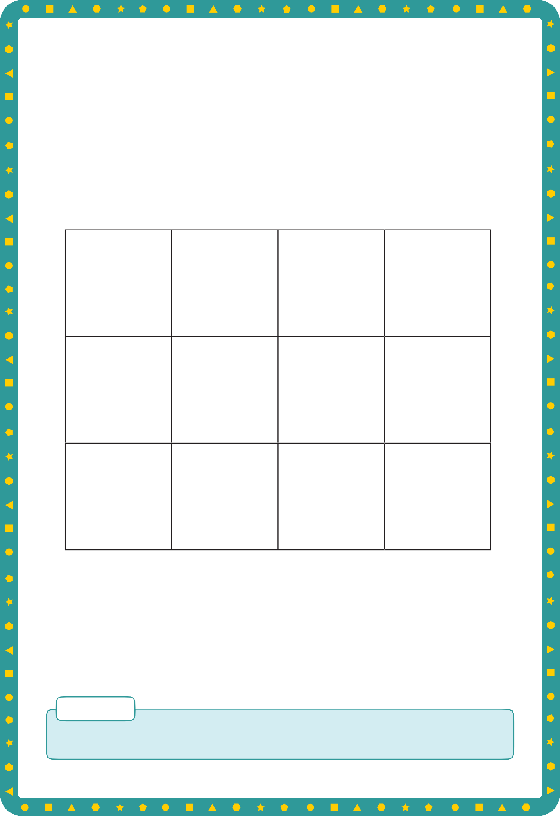
Multiples of 3

Sheet 3

Identify which of these numbers are multiples of 3.

8 | 12 | 39 | 24
22 | 45 | 50 | 18
27 | 41 | 37 | 31

Challenge
Find 4 numbers larger than 50 that are multiples of 3.

© Hamilton Trust practice_frac-mult_12572 _day3



