Friday 22nd January

How can we change the size of a shadow?

Watch this video of a shadow puppet maker: https://www.bbc.co.uk/bitesize/clips/z87jmp3

Now watch this clip about materials affecting shadows:
https://www.bbc.co.uk/programmes/p011sl3m

Now, make your own puppet (keep it simple!) and set up a shadow screen to test it out.
Your shadow screen could just be a piece of paper held up with sticks or a book, or you could use a sheet or other thin piece of fabric. It must be white though.

Spend some time playing with your puppet to explore the shadows it makes – can you change the size of the shadow it makes?

Write down what you notice about the size of the shadow here:

How does the distance between the puppet and the light source affect the size of the shadow created?

The answer to your first question will help you with this one, but now you need to be a bit more scientific.

Using your screen, puppet and a torch, can you find out some information for other puppeteers to use that will help them to know exactly how far from the light source their puppet must be for a particular size of shadow?

Use this picture to help you work out how to set up your experiment and make it a fair test:  What will you keep the same in your investigation?  What will you change? | 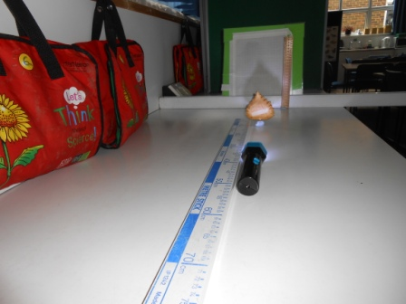

You can set out your investigation however you like, but you will need to explain what you did (Method) and show your findings (Results).

