How does the angle of light affect the length of the shadow of an object?

Find an opaque (not see-through) object like a domino, building block or a rubber for your experiment.

Stick the angles sheet (on the website) on the side of a cereal/shoe box. Your chosen object can be placed at the bottom corner of the box, where the drawn lines start from (have a look at the picture below to help you).

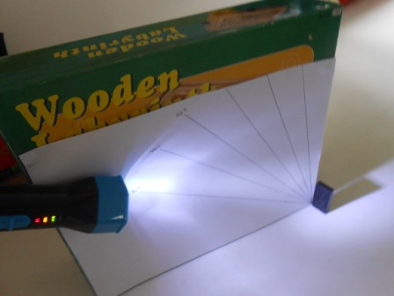

Now you can shine the torch at your object from different angles.

Prediction
What do you think will happen to the length of the shadow when you move the torch up an angle? Write your answer here:

Recording
Use the table below to record the length of shadow when the torch is at 30, 40, 50, 60, 70, 80 and 90 degrees.

Angle of torch (in degrees) | Length of shadow (in cm)
30
40
50
60
70
80
90

Conclusion
What did you find out? Was your prediction correct? Write your answer here:

CHALLENGE:
Can you predict the lengths of the shadows for an object that is double the height of the one that you have already tested? Can you test it out? What do you find?

