Big Question: How is the Trinity described in the Bible and by Christians?

Look carefully at the words in the three columns below.

The words in each column are describing one part of the Trinity.
What heading would you give each column? Father, Son or Holy Spirit?
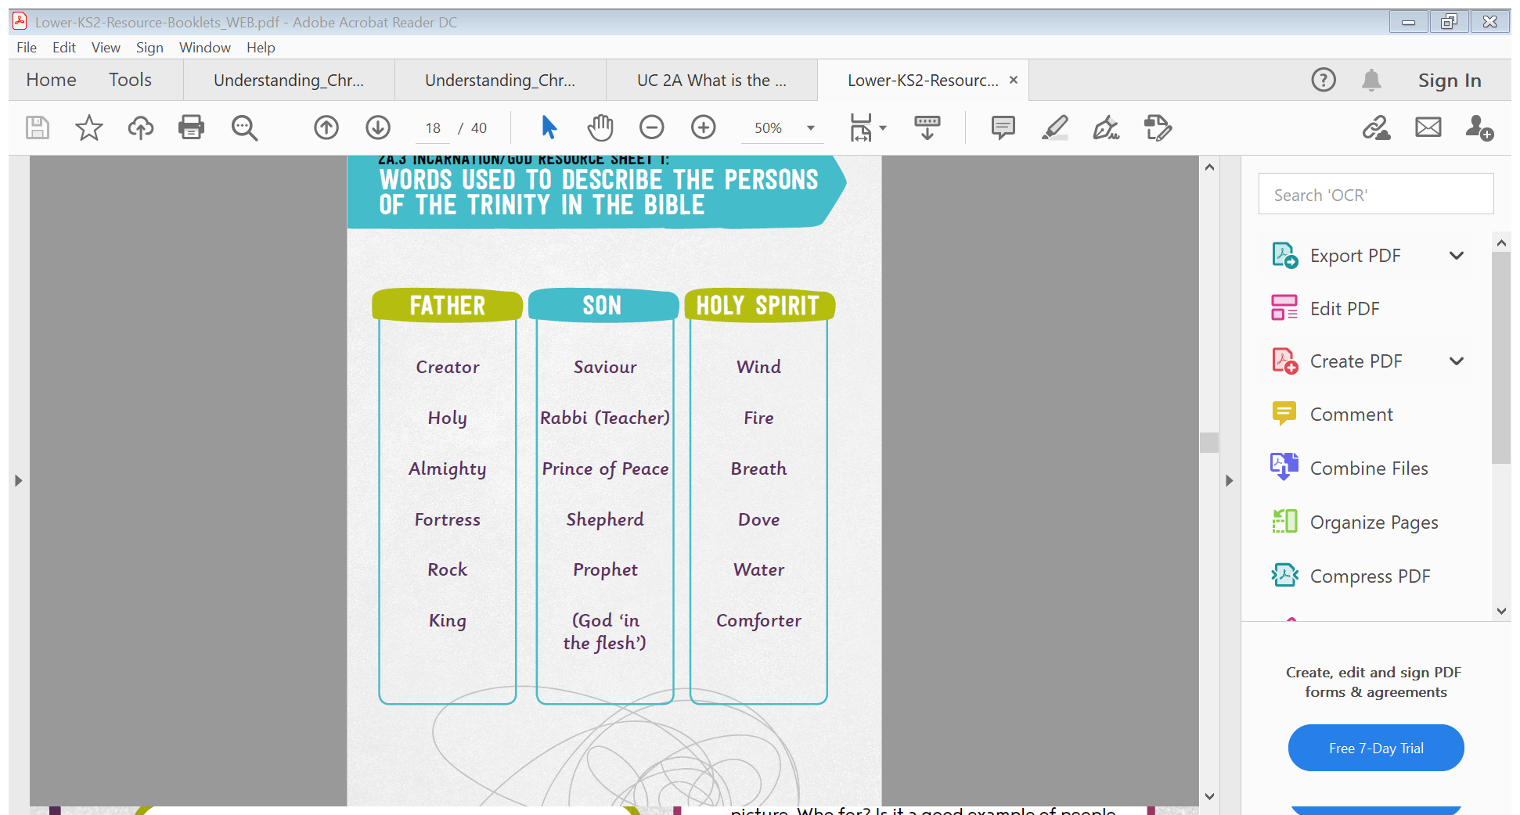

Tell me more about why you gave each column that heading.

Here are some pictures to represent the Trinity. Can you spot any of the words/descriptions used in the columns above?

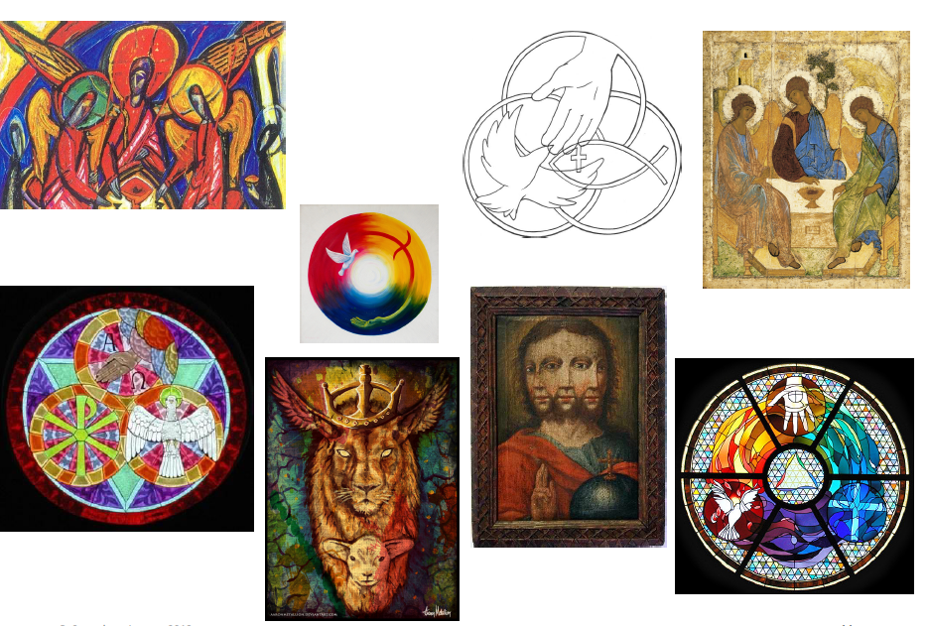

What do you notice about these images?
What is similar?
What is different?
Annotate the images with your thoughts.

How do you think these images represent The Trinity?

