Overjoyed
Excited
Hopeful
Calm
Unsure
Worried
Upset
Distraught
 | 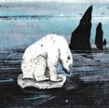 |  |  |  | 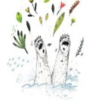 | 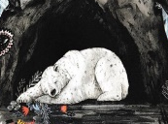 |  | 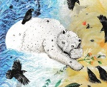 | 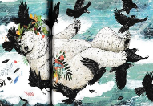



Friday 5th February – Sessions 1 and 2

- Using the pictures along the bottom of page 1, practise retelling the story of Leaf to someone. Try to include all the main events (in the pictures) and how Leaf was feeling at each point.

- Using the 8 pictures of Leaf’s face at the top of this page, create a ‘Graph of Emotion’ to show how he was feeling at each part of the story. You will need to cut these pictures out and place them in the square that you think he is feeling, above the event in the story. An example might be:
Overjoyed


- When you have finished your graph, use it to help you retell the whole story of Leaf, from his point of view. You will need to practise it lots of times so that you remember to include all the events and how Leaf felt at each one. You can create a video of your story to send in – this will be very helpful for next week when we write our version of Leaf.

