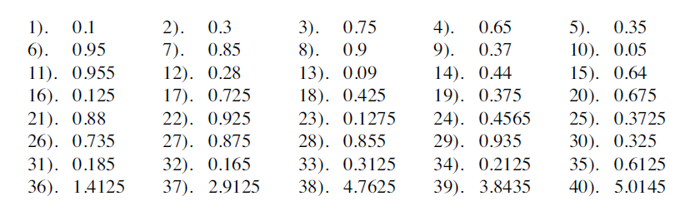
Change each decimal to a fraction or mixed number

