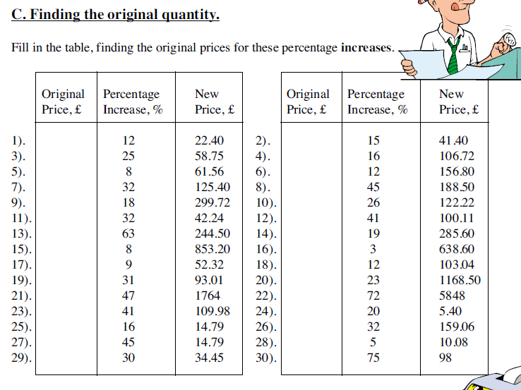
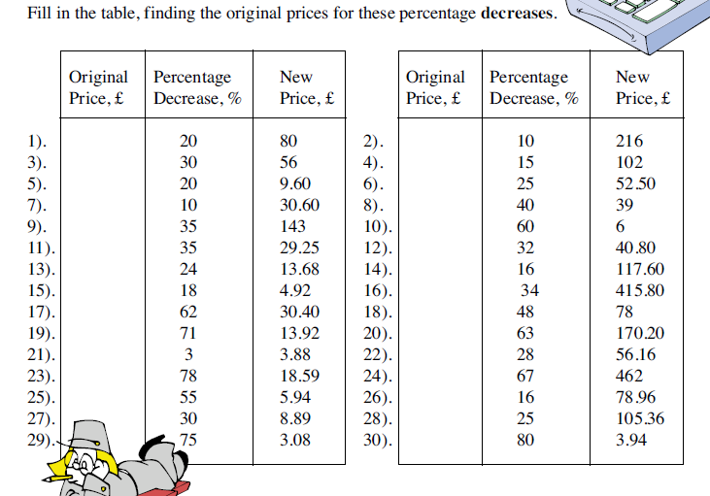
Copy the table and find the original prices for these percentage decreases.
Copy the table and find the original prices for these percentage increases.

