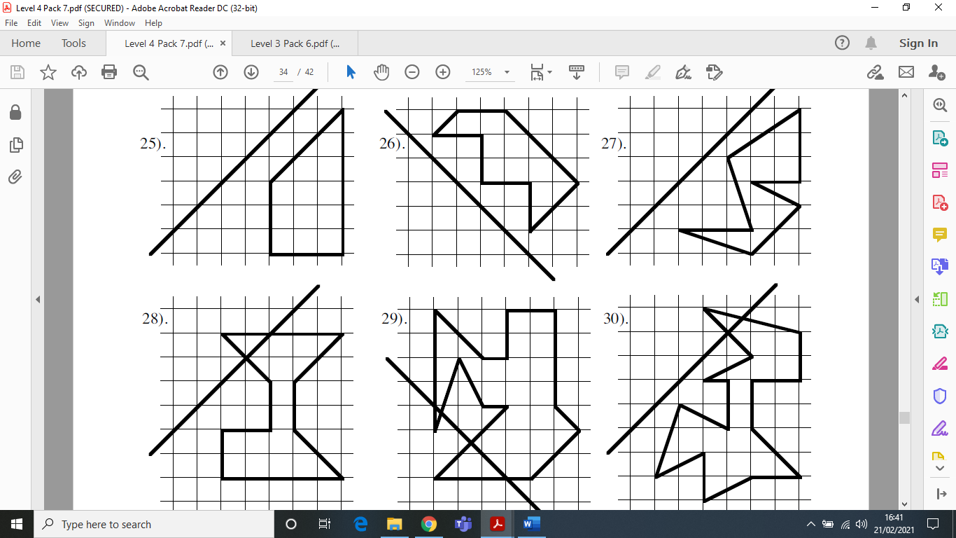
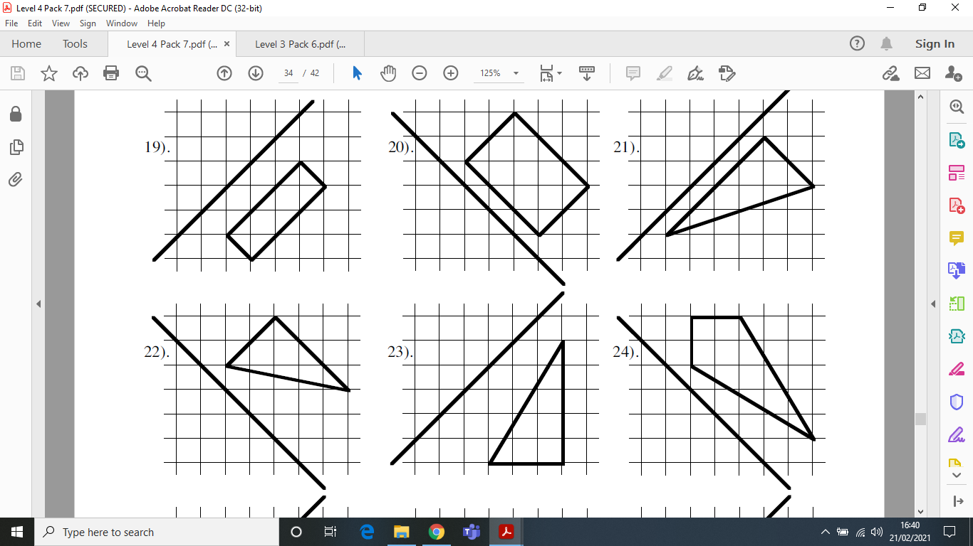
Reflection 3
Draw the following diagrams in your book and reflect each shape across the mirror line. Take care (when copying) to make sure you have the right shape to start with.

